**PROJECT REPORT by Group - 7**

Abstract

Credit Risk Analysis using Exploratory Data Analysis, Feature Selection, Model building, and Visualizations using variety of libraries and tools.

**CREDIT RISK ANALYSIS**

*Mitigate your risk.*

Table of Contents

Section 1: ABSTRACT 1

Section 2: INTRODUCTION 2

Section 3: PROBLEM STATEMENT 3

Section 4: LITERATURE REVIEW 4

Section 5: METHODOLOGY 7

Section 6: ANALYSIS AND INTERPRETATION 19

Section 6.1: PYTHON 19

Section 6.2: TABLEAU 20

Section 6.3 : STREAMLIT 28

Section 7: REFERENCES 33

# Section 1: ABSTRACT

The majority of banks are eager to offer their clients credit—a form of high-quality financial assistance—in order to support the expansion of the nation's gross domestic product (G.D.P.). For all project firms and sponsors, acquiring enough money through the debt channel is a crucial role. Lenders often need to determine the project company's capacity to service principal and interest payments prior to disbursing a loan. Lenders will be able to assess their exposure to default risk by keeping track of changes in the project company's credit rating. The sort of proposed financing should be taken into consideration as a starting point when evaluating a company's creditworthiness. It is crucial to verify this before examining the borrower's financial situation since various forms of lending include different risks.

# Section 2: INTRODUCTION

Every element of a business operation has some level of risk. However, managing credit risk is a crucial aspect for banks and other financial organizations. Credit risk is the chance that a borrower or counterparty won't fulfill their commitments in line with the conditions set forth in the contract. Therefore, credit risk results from the bank's interactions with or lending to businesses, people, and other banks or financial institutions. Maintaining credit risk exposure within appropriate and acceptable bounds is the aim of credit risk management in banks. Understanding the sufficiency of a bank's capital and loan loss reserves at any one moment is the practice of loss mitigation. Banks must manage both the overall portfolio and specific credits in order to do this. The balance sheet and income statement of the business are the main focus of traditional credit analysis to ascertain if a borrower is producing enough cash flow to pay its loans. A combination of industry, business plan, and management skill analyses may be used to determine whether or not there will be enough cash flow to cover current obligations for the foreseeable future and whether or not liabilities are expected to increase or decrease. Failure of a commercial bank is typically attributed to issues with the credit portfolio and is less frequently brought on by a decline in the value of other assets. As a result, the loan portfolio is crucial to the bank's success in addition to playing a prominent role in the bank's organizational structure.

A transaction between two parties in which one (the creditor or lender) provides money or products, services, or other items in exchange for a commitment from the other (the debtor or borrower) to make a future payment is referred to as a credit transaction. The capacity and desire to repay the credit determine credit losses. The causes can range from increased competition, new technology, substitutes, price increases, declining demand, overestimated demand, an oversupply position in the market, government regulations, poor management, the demise of key individuals, business cycles, overly ambitious projects, financial losses, excessive leverage, concentrated exposure, poor diversification, and more. Only a thorough examination of credit risk will reveal the likelihood of credit loss resulting from real business causes and look into potential mitigations for this worrying scenario to put a stop to it.

The chance of loss (due to non-recovery) resulting from the credit granted, as a consequence of the counterparty's lack or reluctance to fulfill contractual commitments, or for any other cause, is known as credit risk. The credit risk involved is high if the likelihood of the loss is high, and vice versa. By keeping credit risk exposure within the risk inherent in the overall portfolio as well as the risk in specific loans or transactions, credit risk management aims to reduce a bank's risk-adjusted rate of return.

# Section 3: PROBLEM STATEMENT

The bank's revenues are entirely reliant on the loans and advances that fuel expansion in both the economy and industry. As a result of the borrower's failure to repay the loan, the bank faces a greater credit risk. Loans and advances are the primary sources of credit risk that arise from bank activities for many financial institutions.

In addition to advances, banks are increasingly contending with credit risk in a variety of financial instruments, such as affirmation, entomb bank trades, trade financials, remote exchange trades, cash-related destinies, swaps, securities, equities, options, as well as in the expansion of duty and guarantees and the settlement of transactions. Therefore, it is important to research the causes of credit risk as well as methods for managing or reducing it.

# Section 4: LITERATURE REVIEW

The authors Meighs and Frank E (2012) in their paper discussed the relation to interest rate swaps, analysis using traditional credit instruments allows the credit officers to adequately manage a different source of credit risk. End users of financing interest rate swaps can significantly lower their risk of default by purchasing insurance. It serves as a new tool for managing the risk associated with providing credit to customers. Authors also described Customer satisfaction and credit risk management and demonstrated the beneficial link between credit risk management and customer happiness, and it is unnecessary for bank management to focus on any other aspects outside credit issuing that affect customer satisfaction. In order to increase earnings, the bank must concentrate on its lending policy.

Credit risk management and customer satisfaction were described by authors Parsley & Mark in 2011. It demonstrates the link between credit risk management and customer happiness, and it is unnecessary for bank management to focus on aspects other than credit giving that affect customer satisfaction. In order to increase earnings, the bank must concentrate on its lending policy. The authors also analyzed how microscale banks manage credit risk and execute in advance. The investigation's findings show that there is a relationship between the loan term and advance execution. The gathering strategy and credit risk management are positively related, although they have a negligible impact on the advance.

The authors Weber, Olaf, Fenchel, Mareus, Scholz & Roland W (2014) investigated how banks reconciled natural risks into their credit risk administration methods and techniques. They discovered significant differences in how banks that have signed the UNEP proclamation by the banks on the earth have integrated environmental risks as well as banks that have not yet agreed to this arrangement. The authors also reviewed how operational risk, interest rate risk, cash chance, and liquidity risk have been added to asset and liability management. Investors may prepare for any instability by using modeling that takes into account all the risk factors.

According to Jobs, Norbert J. Zenios, and Stavros A. (2015), spread risk and interest rate risk are essential factors that won't go away in a large portfolio setting, especially when premium instruments are taken into account. Banks should concentrate on limiting such risks in order to achieve long-term growth at the corporate level. discovered a cutting-edge approach for looking at financial elements of banks from a risk management standpoint. This evaluation assists in developing broad ratings of banks' risk management capabilities. Since risk management is thought to be a key factor in determining a bank's stock return, the bank should adapt its whole toolkit to manage credit risk and encourage stock returns to an added level.

WORLD STATISTICS:

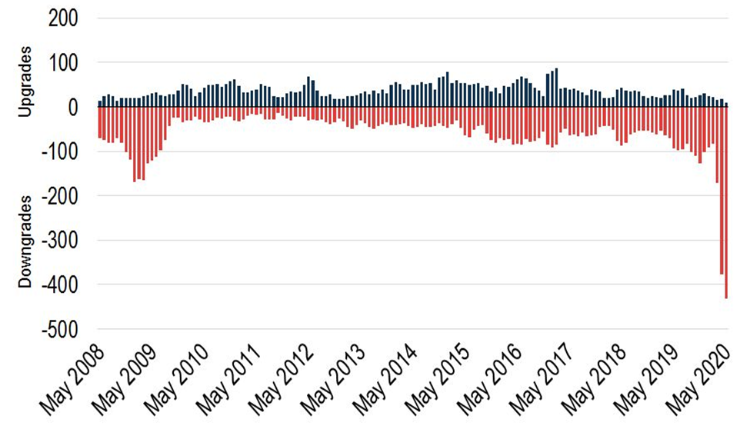

Even though there were 90 loans downgraded in May, down from a record 228 in April and 114 in March, the rate is still high by historical standards. Comparatively, there were just 26 loan downgrades in December.

The ratio of downgrades to upgrades on a rolling three-month basis increased to 43.2x in May, setting yet another record high value. Up from 22.1x in April and 11.4x in March, respectively.

The B- cohort's makeup has considerably changed as a result of the increasing downgrades. Since March 1, $79.4 billion, or nearly 30%, of the $269 billion in loans presently falling into this rating category have been reduced to this level.

For example, just $55 billion out of $320 billion of B flat outstandings are the result of post-coronavirus downgrades. The recent uptick in downgrades had the most effect on the CCC+ bucket; of the $86.6 billion in outstanding debt, 71%, or $61.9 billion, was the consequence of a downgrading in the past three months.

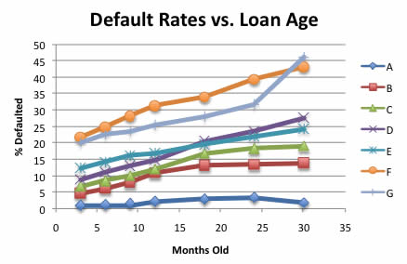

You can compare new loans and old loans on a more equal footing according to this chart, which groups all loans according to their age. No late loans with payments up to 120 days past due are included; only loans that have formally defaulted included. Credit grades A through G are used to order the numbers.

# Section 5: METHODOLOGY

**DATA SELECTION**: Dataset was collected from Kaggle for Analysis. It is composed of two files, current application records containing 122 columns and 300,000 plus rows, and previous applications records containing 37 columns and 100,000 plus rows.

**DATA CLEANING**: The data was cleaned using the Pandas Library. We looked at the data type, statistical overview, and percentage of null values for each column and discovered that certain attributes had missing data and outliers. Since more than 50% of the data in some columns was missing, such columns were found to be unnecessary. Additionally, attempts were made to use Imputation to handle the columns with more than 13% of the data missing. Utilizing the values for the mean, median, mode, and 0 from the designated column description.To give one such example the- in application date, several rows had negative values for "Days" column. They were converted into their absolute value to make future processing easier. Further missing data and extreme outliers for various columns was handled using the appropriate methods (the python notebook could be used for better understanding).

**DERIVING DATA**: The dataset did not have the date of application but many other columns were relative to the date of application. In a traditional relational system, data of application is the system current date on which the applicant has applied for loan. Since this dataset didn’t have that date, we randomly generated dates from the period of 2015 to 2018 so that all the relative columns could be derived with their actual dates.

|  |
| --- |
| *df2['DAY_OF_EMPLOYMENT'] = pd.to_datetime(df2['DATE_OF_APPLICATION']) - pd.to_timedelta(df2['DAYS_EMPLOYED'], unit='d')* |

**DATA TRANSFORMATION**: Date formats were changed to incorporate timestamps. Bins were created for Age category, Income category and put into new columns.For example, after binning of the Annual Income, it was categorized into Low Income, Below average Income, Average Income, Above Average Income, High Income. Binning is a helpful technique for many reasons. Firstly, it can help in identifying characteristics of different categories of a feature. Secondly, it is also useful in the feature selection process .Thirdly, it helps in the reduction of outliers and missing values.

|  |
| --- |
| *#Binning the Annual Income*  *bins = [10000, 500000, 1000000, 1500000, 2000000, np.inf]*  *names = ['Low Income', 'Below average Income', 'Average Income', 'Above Average Income', 'High Income']*  *df2['ANNUAL_INCOME_RANGE'] = pd.cut(df2['AMT_INCOME_TOTAL'], bins, labels=names)* |

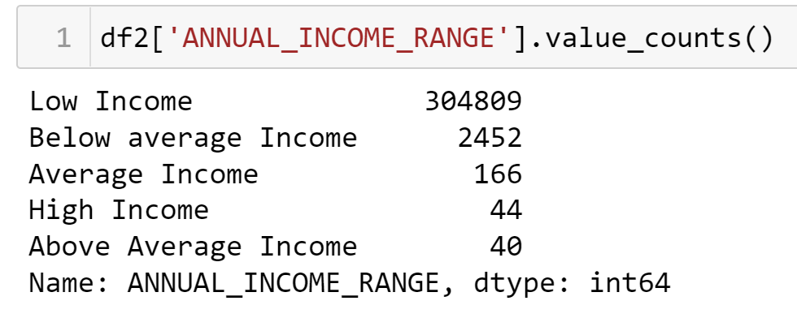

*Income Binning:*

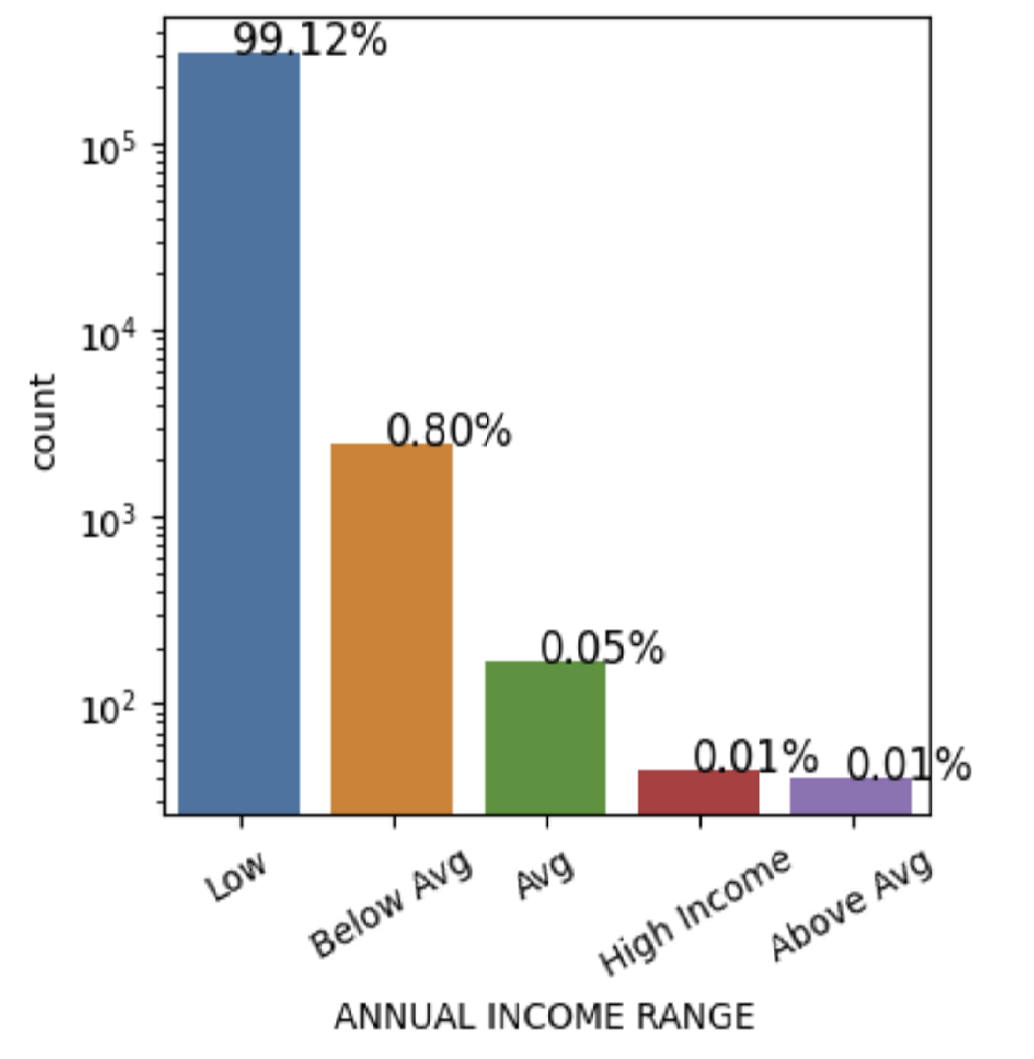

*Age Binning:*

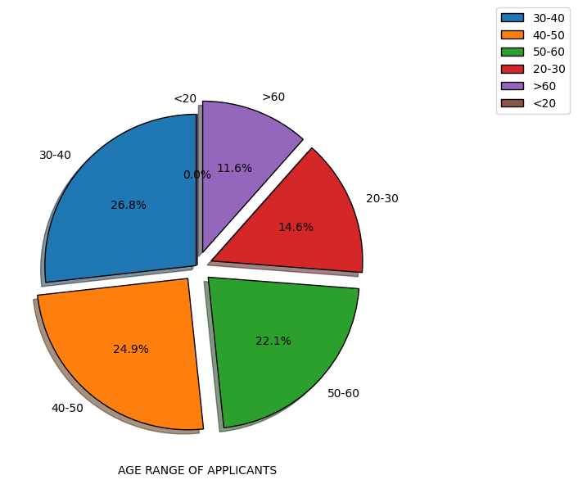

**FEATURE SELECTION**: The data was segregated with respect to Defaulters(Target=1) and Non-Defaulters(Target = 0). Correlations between different features were calculated to figure out which features are linked to each other in both the target categories.

*Target Distribution in dataset*:

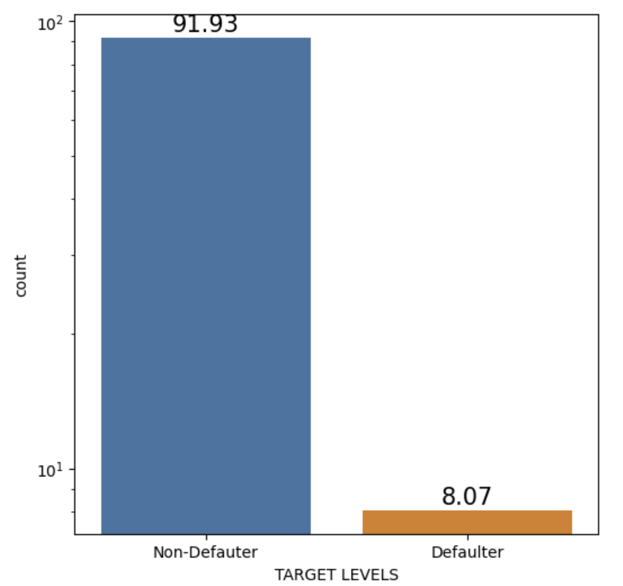

*Target=0 Correlation*

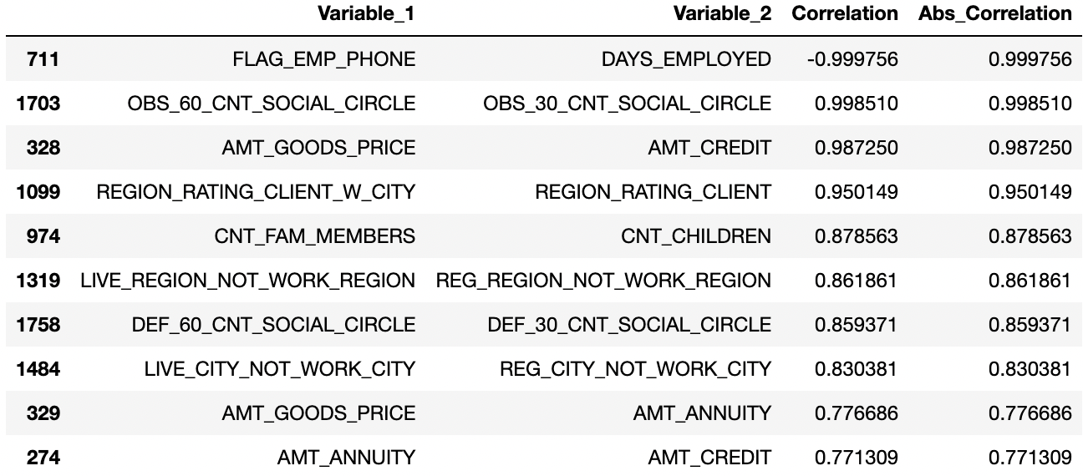

*Target = 1 Correlation*

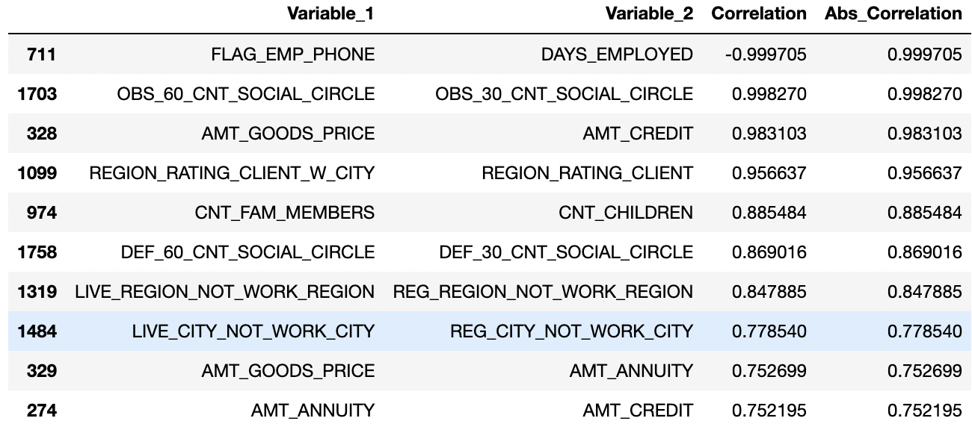

*Correlation for Target=1(Defaulter):*

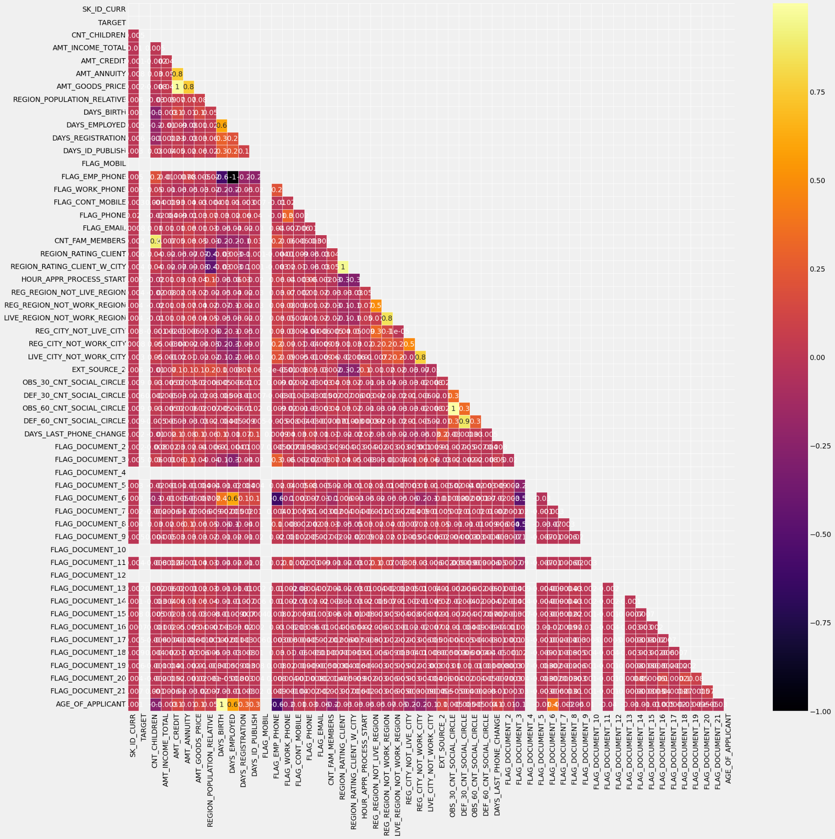

*For clarity, correlation of few fields:*

|  |
| --- |
| *df_temp1 = df2[['TARGET','CNT_CHILDREN','AMT_INCOME_TOTAL','AMT_CREDIT','AMT_ANNUITY','AMT_GOODS_PRICE','REGION_POPULATION_RELATIVE']]*  *find_correlation(df_temp1)* |

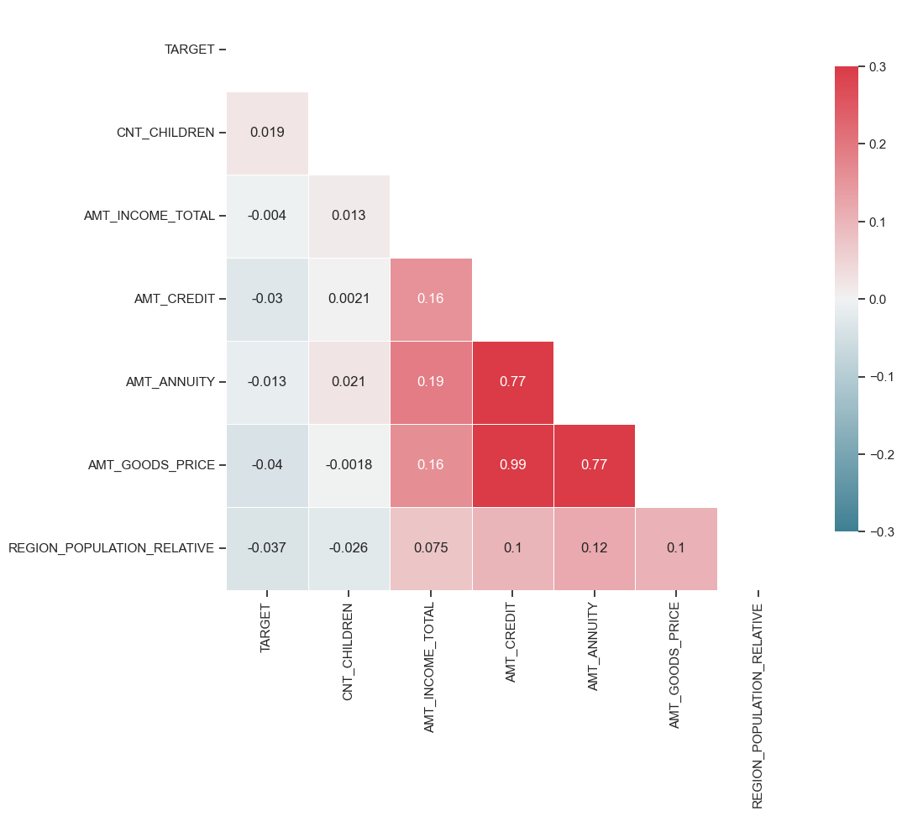

*Pairplot of few features with respect to target*

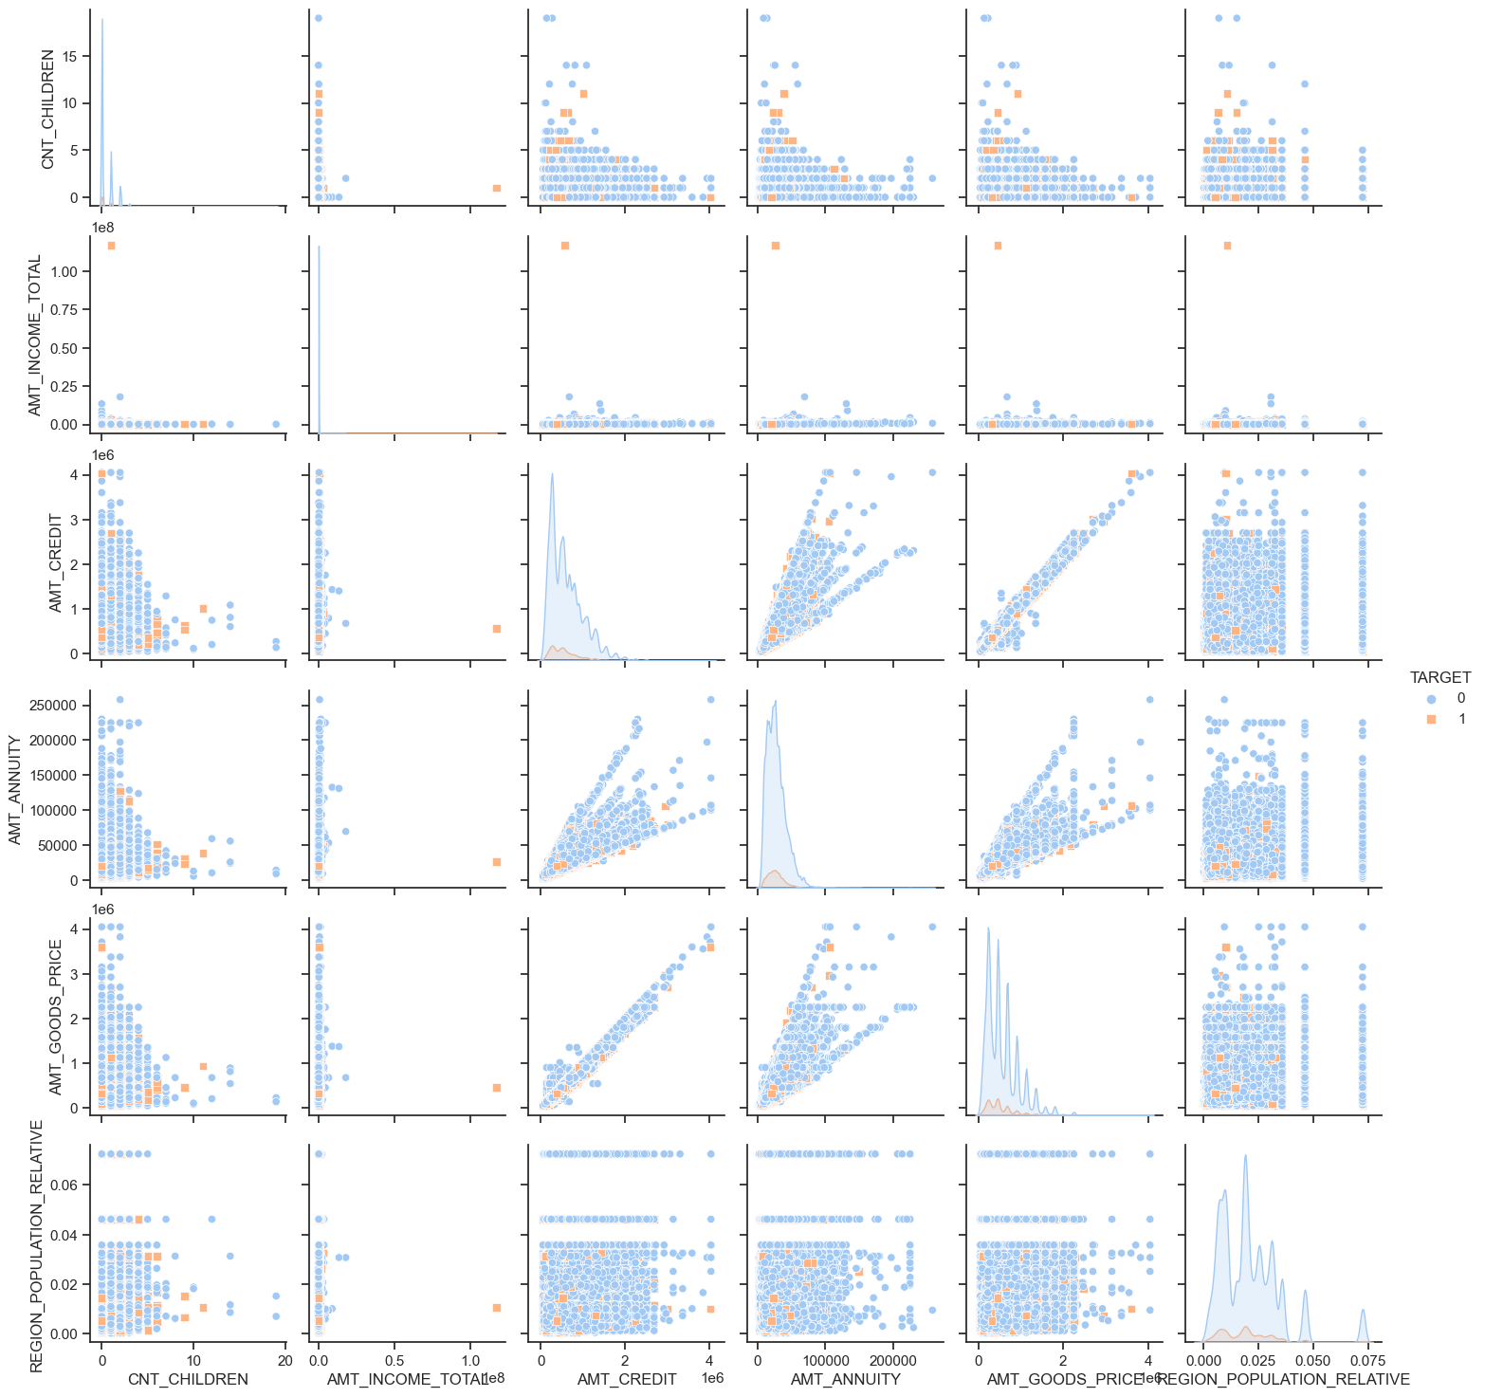

**Binning, Weight of Evidence (WoE), Information Value (IV)**

Weight of evidence and Information value are the strong techniques that have emerged from the credit scoring world. They have been used as a benchmark to screen variables in the credit risk modeling projects such as probability of default. The weight of evidence states the predictive power of an independent variable in relation to the dependent variable. It is often described as a measure of the separation of non-defaulters and defaulters.

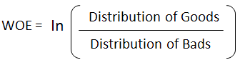

***Distribution of Goods -*** *% of Good Customers in a particular group*

***Distribution of Bads -*** *% of Bad Customers in a particular group*

***ln -*** *Natural Log*

Positive WOE means Distribution of Goods > Distribution of Bads

Negative WOE means Distribution of Goods < Distribution of Bads

**(**Log of a number > 1 means positive value. If less than 1, it means negative value.)

*Or can be written as:*

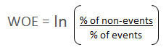

**Steps of Calculating WOE**

For a continuous variable, bin the data into 10 parts (or lesser depending on the distribution).

Calculate the number of events and non-events in each group (bin)

Calculate the % of events and % of non-events in each group.

Calculate WOE by taking natural log of division of % of non-events and % of events

Note : For a categorical variable, you do not need to split the data (Ignore Step 1 and follow the remaining steps)

Binning creates buckets of independent variables based on ranking methods. Binning helps us convert continuous variables into categorical ones based on similarity of dependent variable distribution i.e. number of events and non-events.

**For continuous independent variables** : First, create bins (categories / groups) for a continuous independent variable and then combine categories with similar WOE values and replace categories with WOE values. Use WOE values rather than input values in your model.

**For categorical independent variables :** Combine categories with similar WOE and then create new categories of an independent variable with continuous WOE values. In other words, use WOE values rather than raw categories in your model. The transformed variable will be a continuous variable with WOE values. It is the same as any continuous variable.

We combine similar WOE categories because similar WOE categories have almost the same proportion of events and non-events. In other words, the behavior of both the categories is same

Weight of Evidence (WoE) will help us to determine which categories should be binned together. WOE measures the strength of a bin in differentiating the Good and Bad accounts. WOE < 0 indicates that the variable bin captures a higher proportion of bad accounts.

Information Value (IV) will help in determining which variables are useful for prediction in the logistic regression model. IV is the measure of overall predictive power of the variables and is very useful for feature selection.

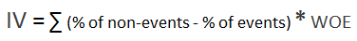

**For our Dataset, we have defined the parameters as below:**

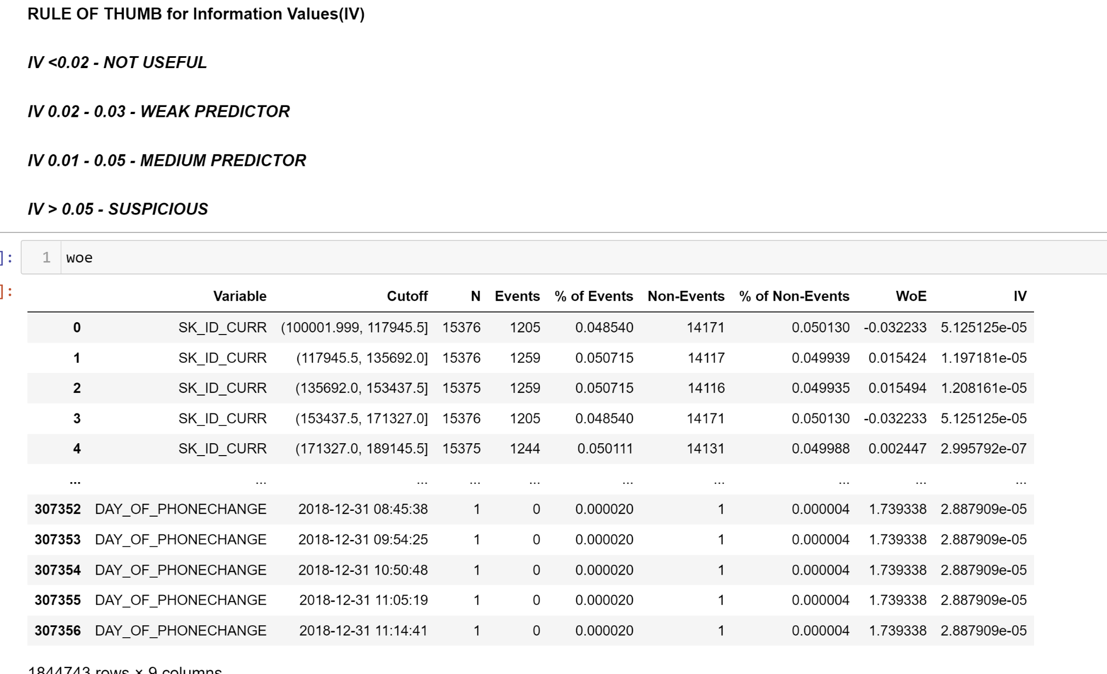

Features that were not significant and suspicious were removed from the Dataframe for the model to process only relevant features. Plot for WOE is created to check the monotonicity and how well the categorical variable separates the target. Example here is given for age:

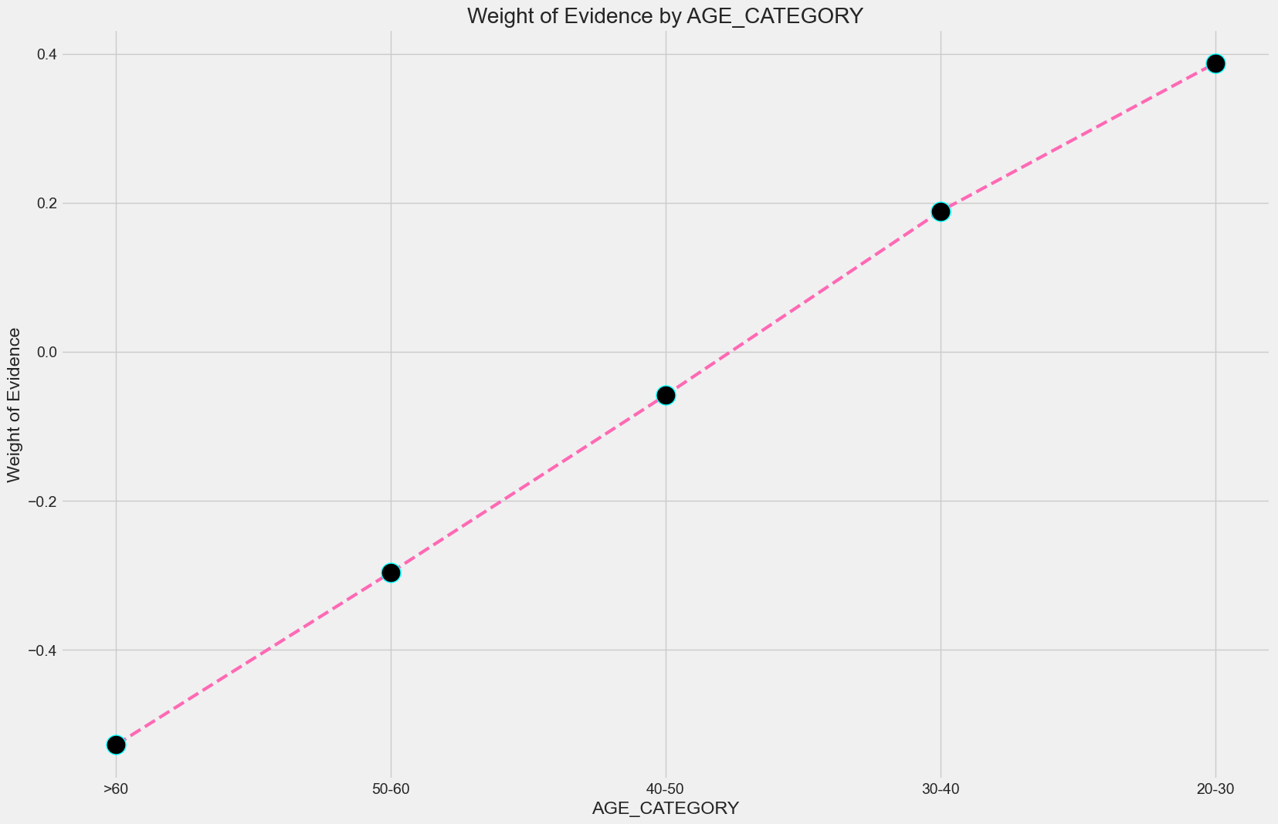

Age is a strong predictor of predicting whether a person is a defaulter or not.therefore, it should be included in the model.

Furthermore analysis of various columns

# Section 6: ANALYSIS AND INTERPRETATION

## Section 6.1: PYTHON

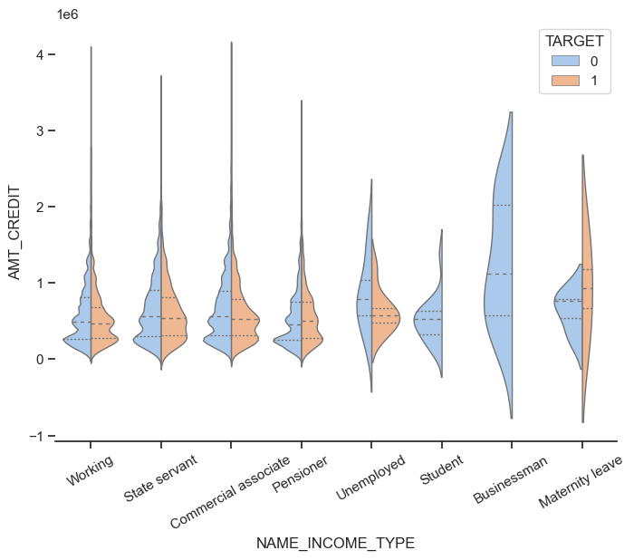

This above Violin plot demonstrated the distribution of defaulters vs non-defaulters according to their income source and credit amount. Students and Businessmen do not seem to be defaulters.

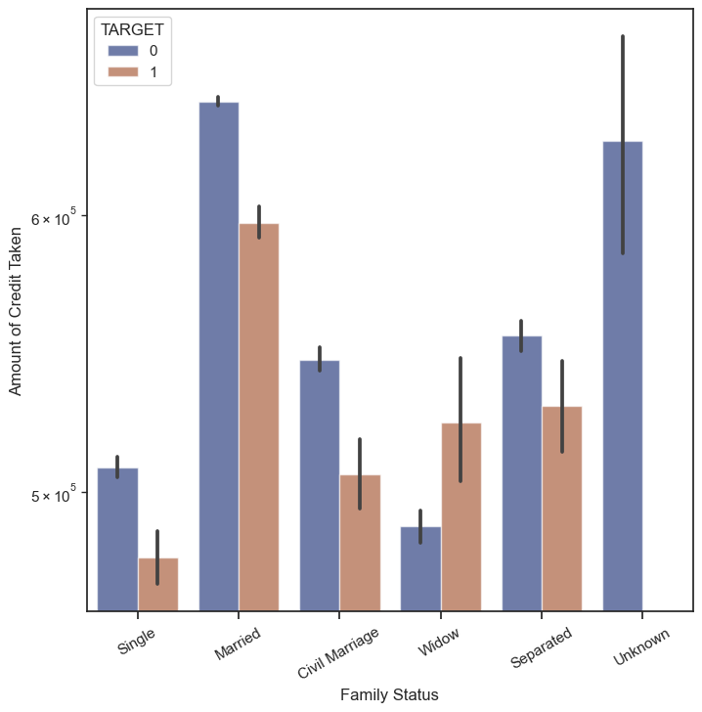

The above chart shows the family status vs the amount of credit taken by Defaulters and non-Defaulters. Married people tops the chart for Defaulters.

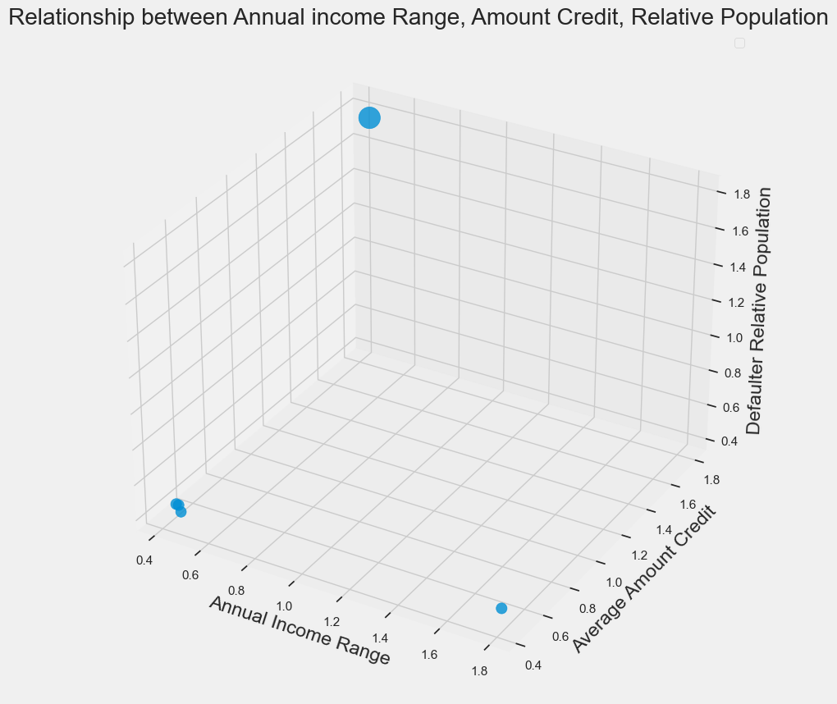

The above 3D graph shows that on an average Low Income Range Defaulters took High Credit Amount and lived in a relatively highly populated area.

## Section 6.2: TABLEAU

In Tableau, we have created some Parameters, Calculated Tables, Calculated Fields and animations to find the hidden patterns that were not apparently available with our dataset.

Some of the important inferences that we observed are:

**DEMOGRAPHICS** of Defaulters:

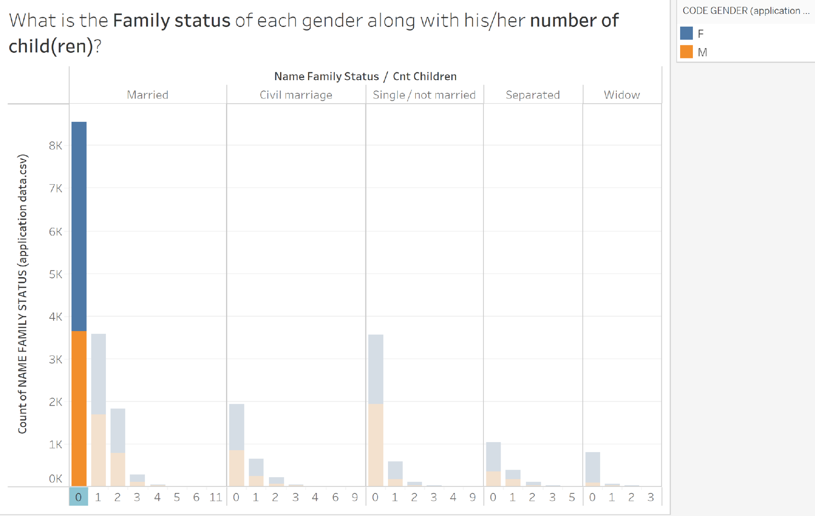

* Most Defaulters were married without children.

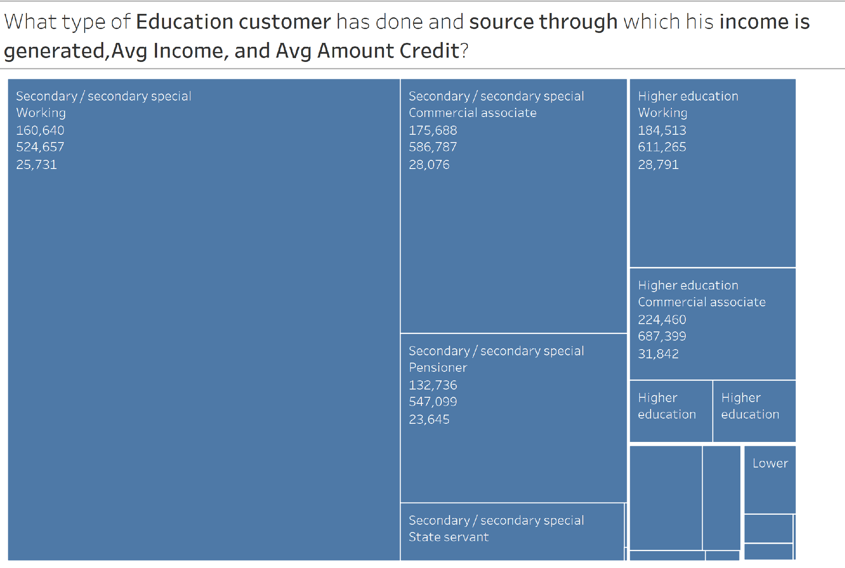

* Most Defaulters were working after doing secondary education. Academics were very less in the Defaulters population.

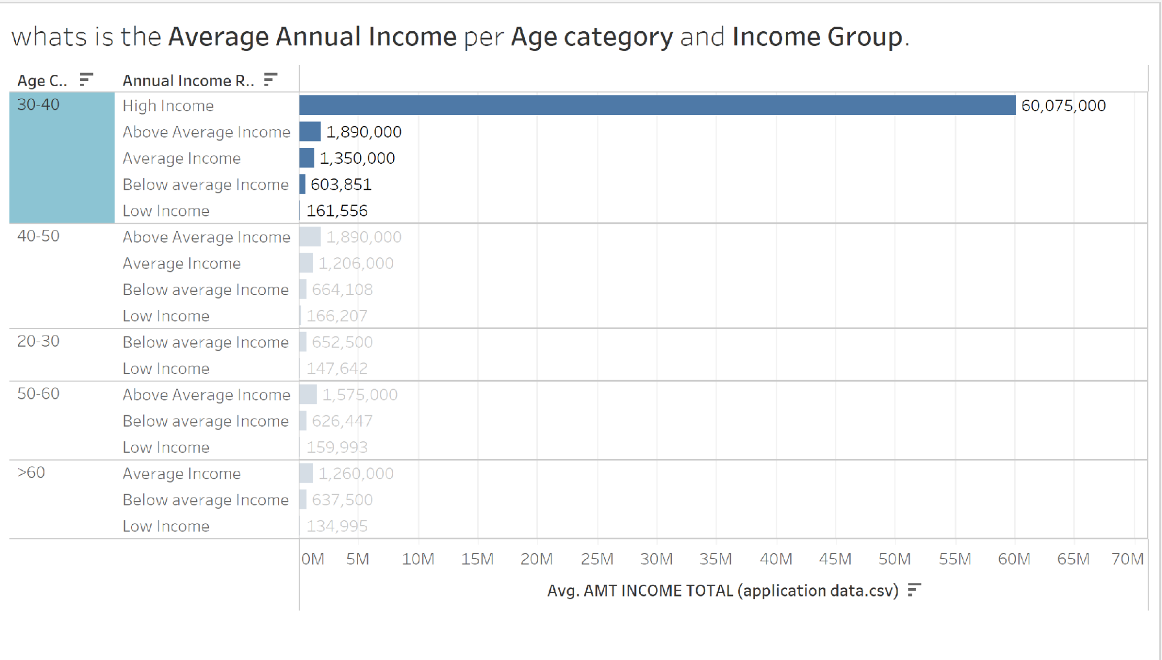

* Most of the Defaulters were from 30-40 years of age lying in the high income group.

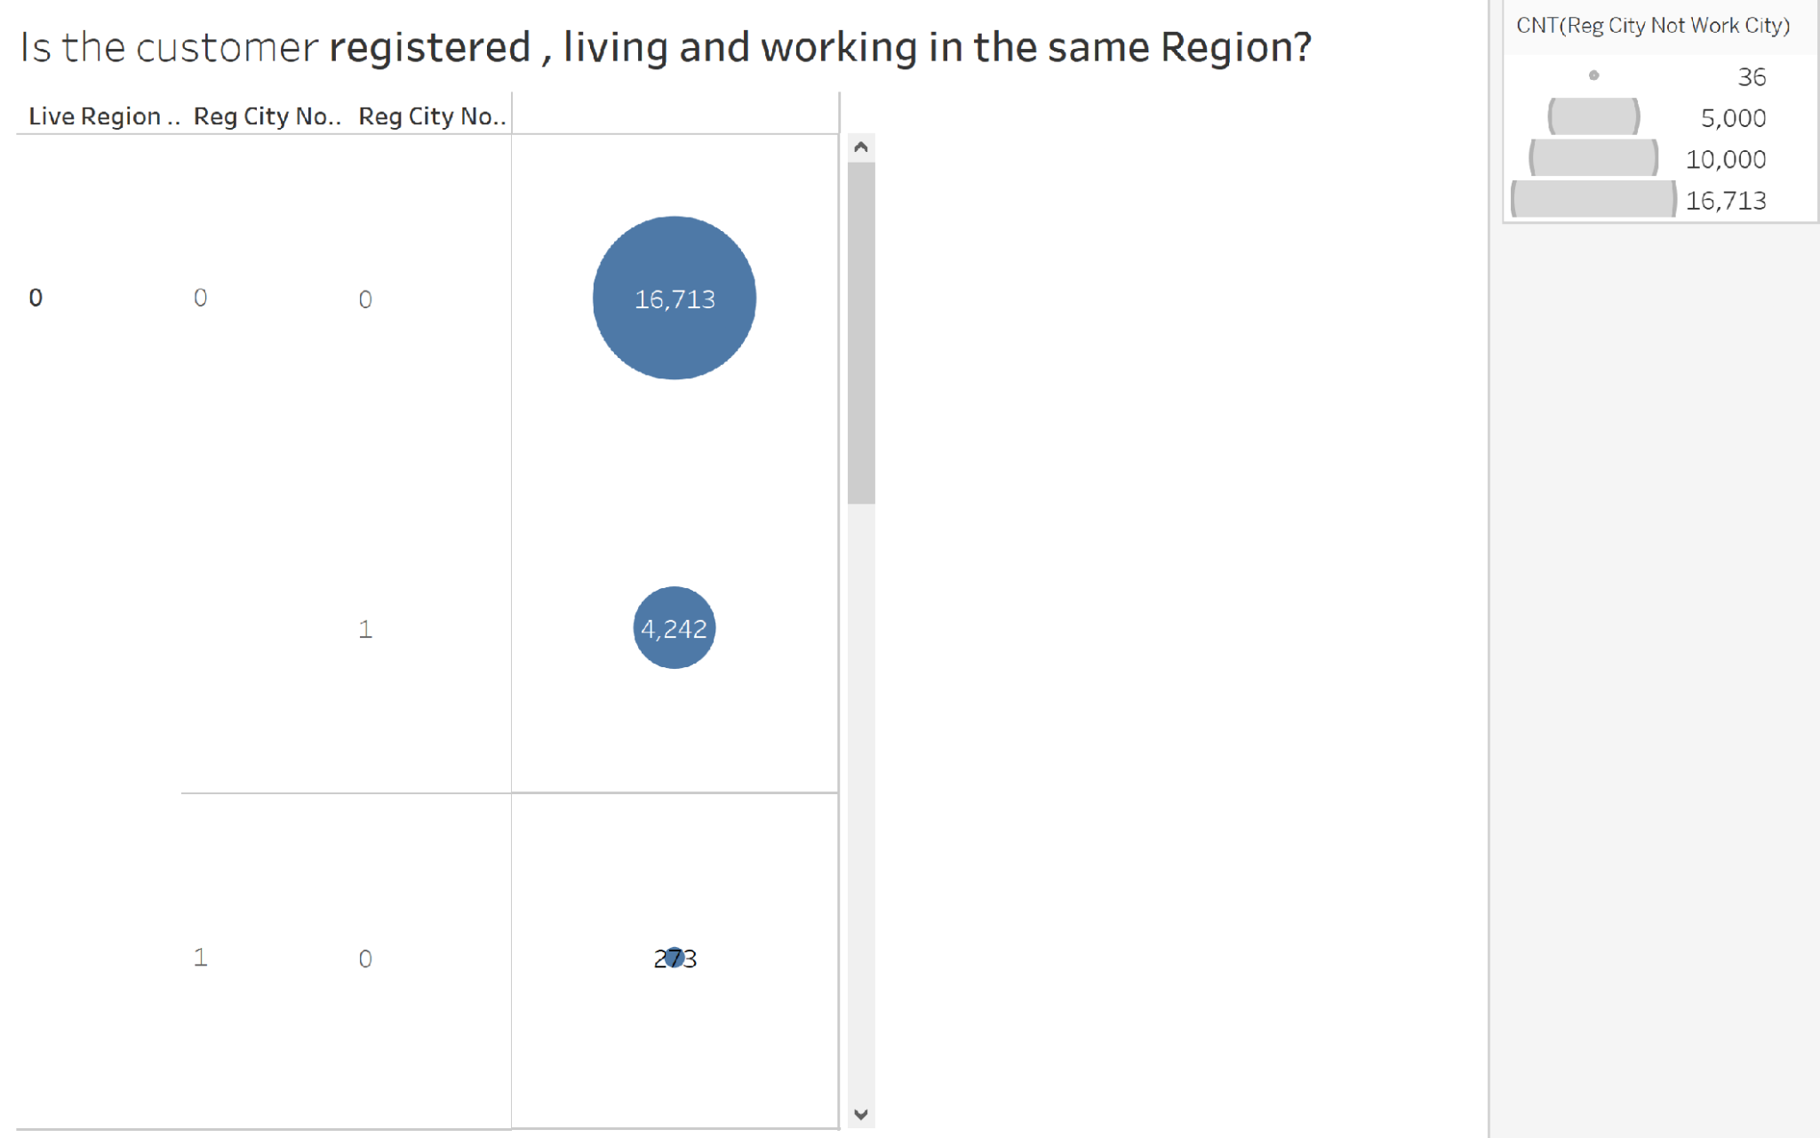

* Most of the Defaulters were registered, living, and working in the same Region.

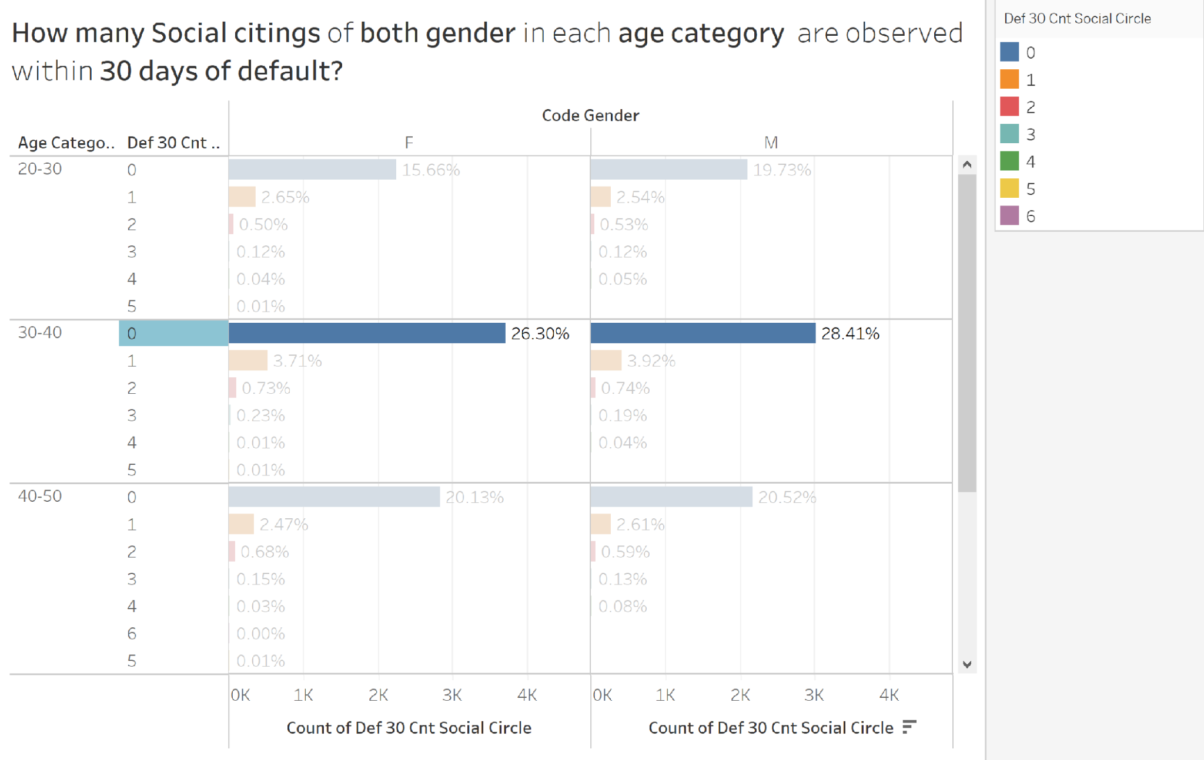

* The proportion of getting socially disconnected was increased by most of the Defaulters within 30 Days of Default.

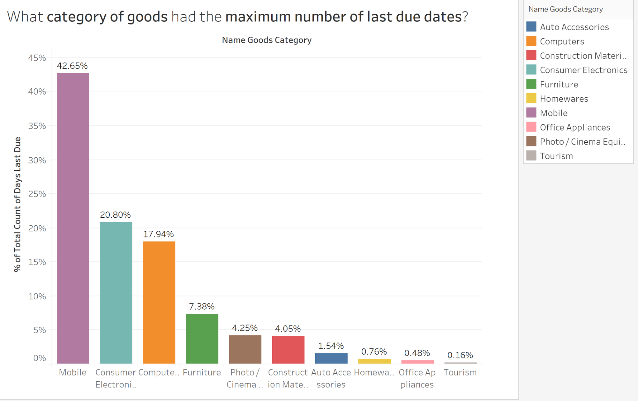

* Mobile and Consumer Electronics were the highest in goods categories for which the number of last payments due days were highest and double in proportion for the Defaulters.

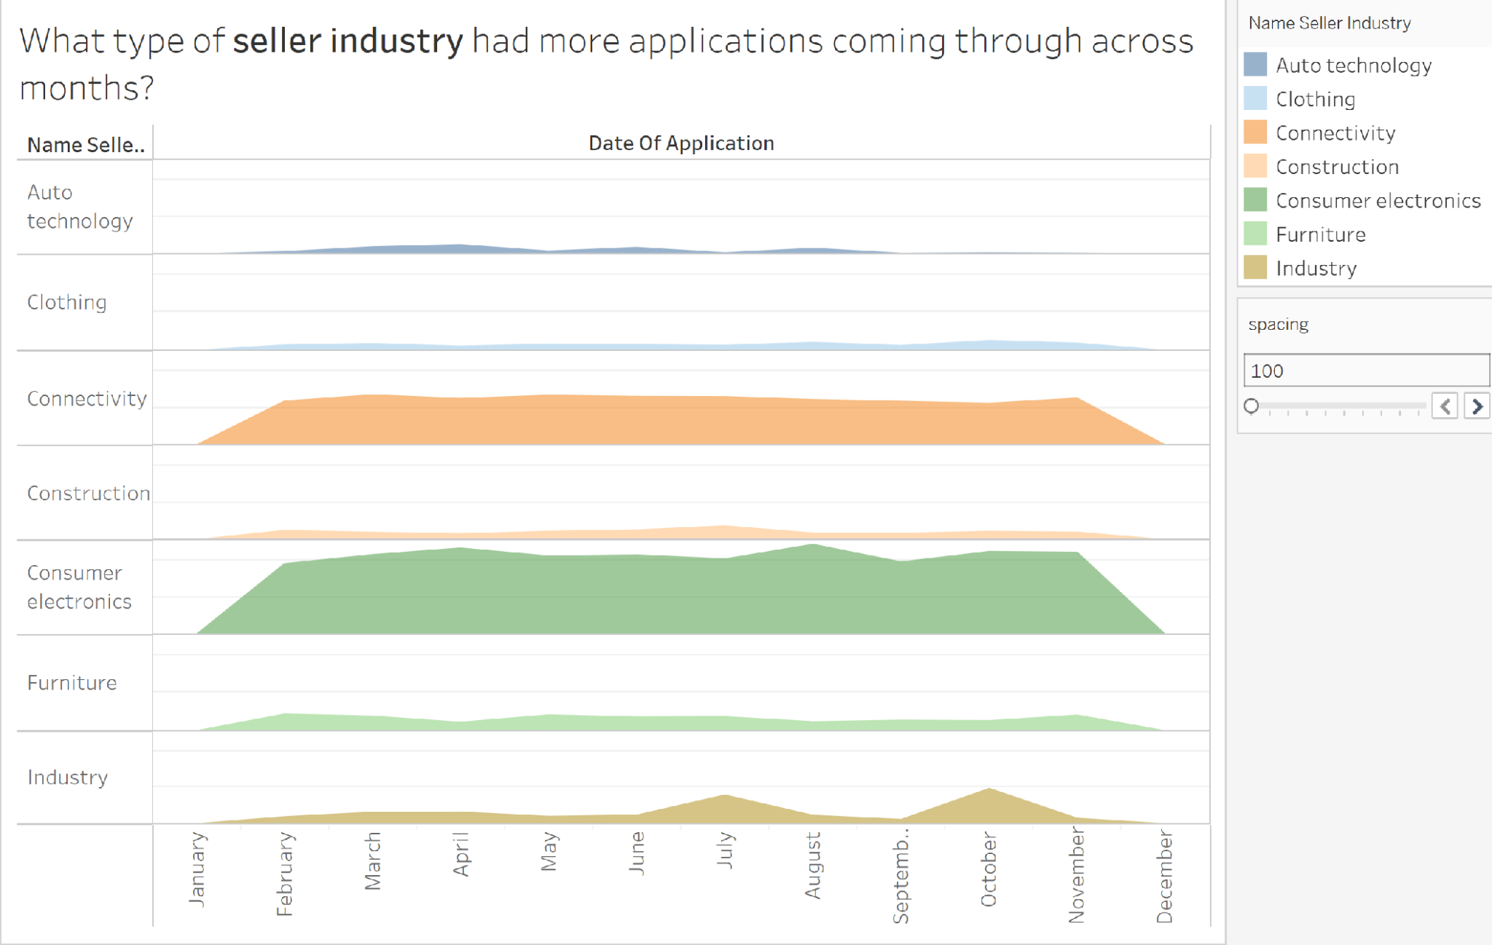

* Ridgeline plot to demonstrate that Connectivity and Consumer electronics got the maximum number of loan applications that increased even more in the case of Defaulters.

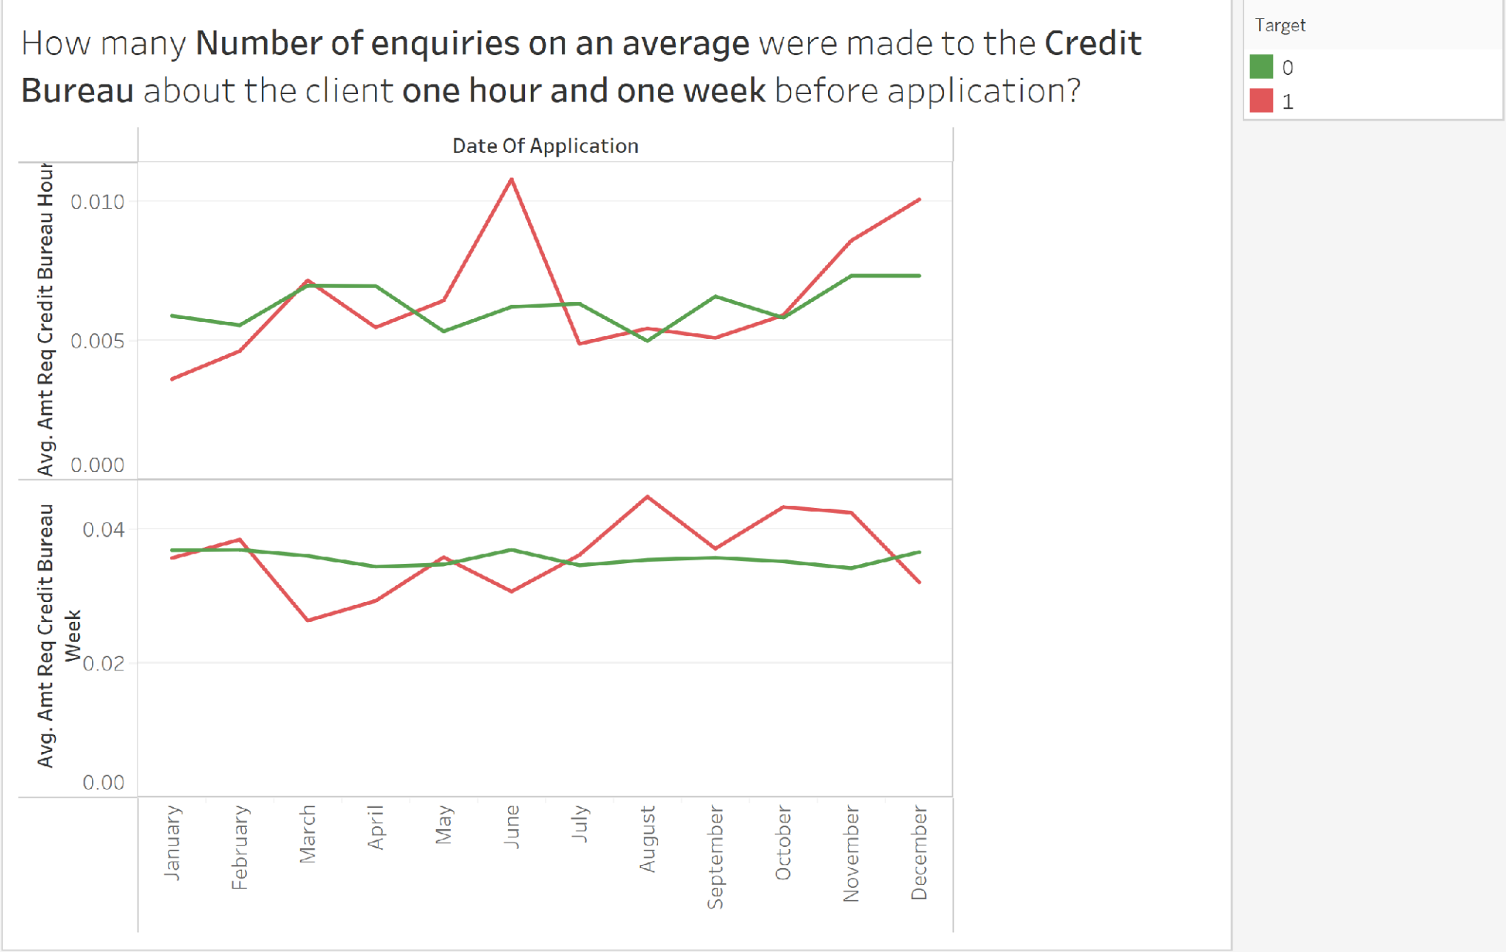

* This plot demonstrates the number of enquiries made to the Credit Bureau within 1 hour and 1 week of the application. For Defaulters, there seems to be a wide variation in the amount of enquiries done to the Credit Bureau.

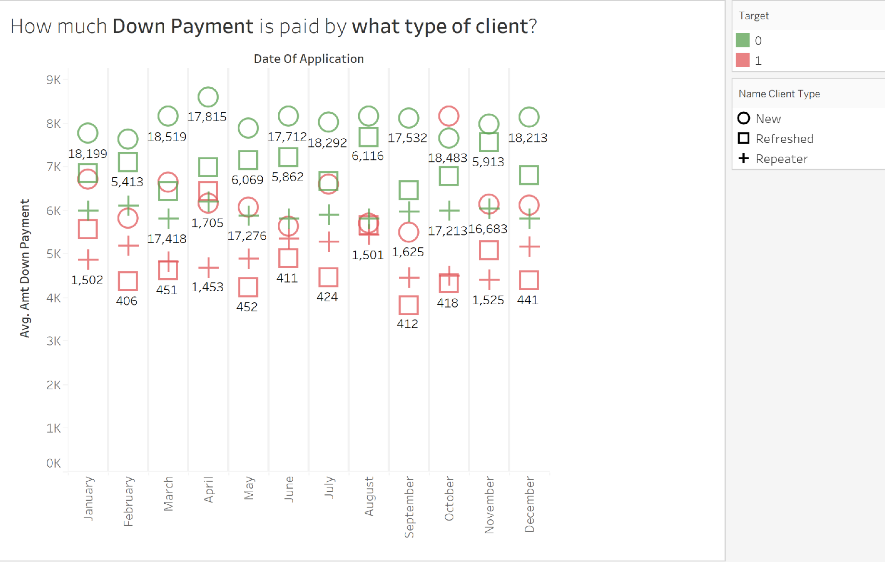

* This chart depicts the clear separation between different types of client such as New, Refreshed and Repeater. Although for both target categories, New client pays the most followed by Repeater and then Refreshed. But the interesting part is that overall, Defaulters tend to pay less down payment than non-Defaulters.

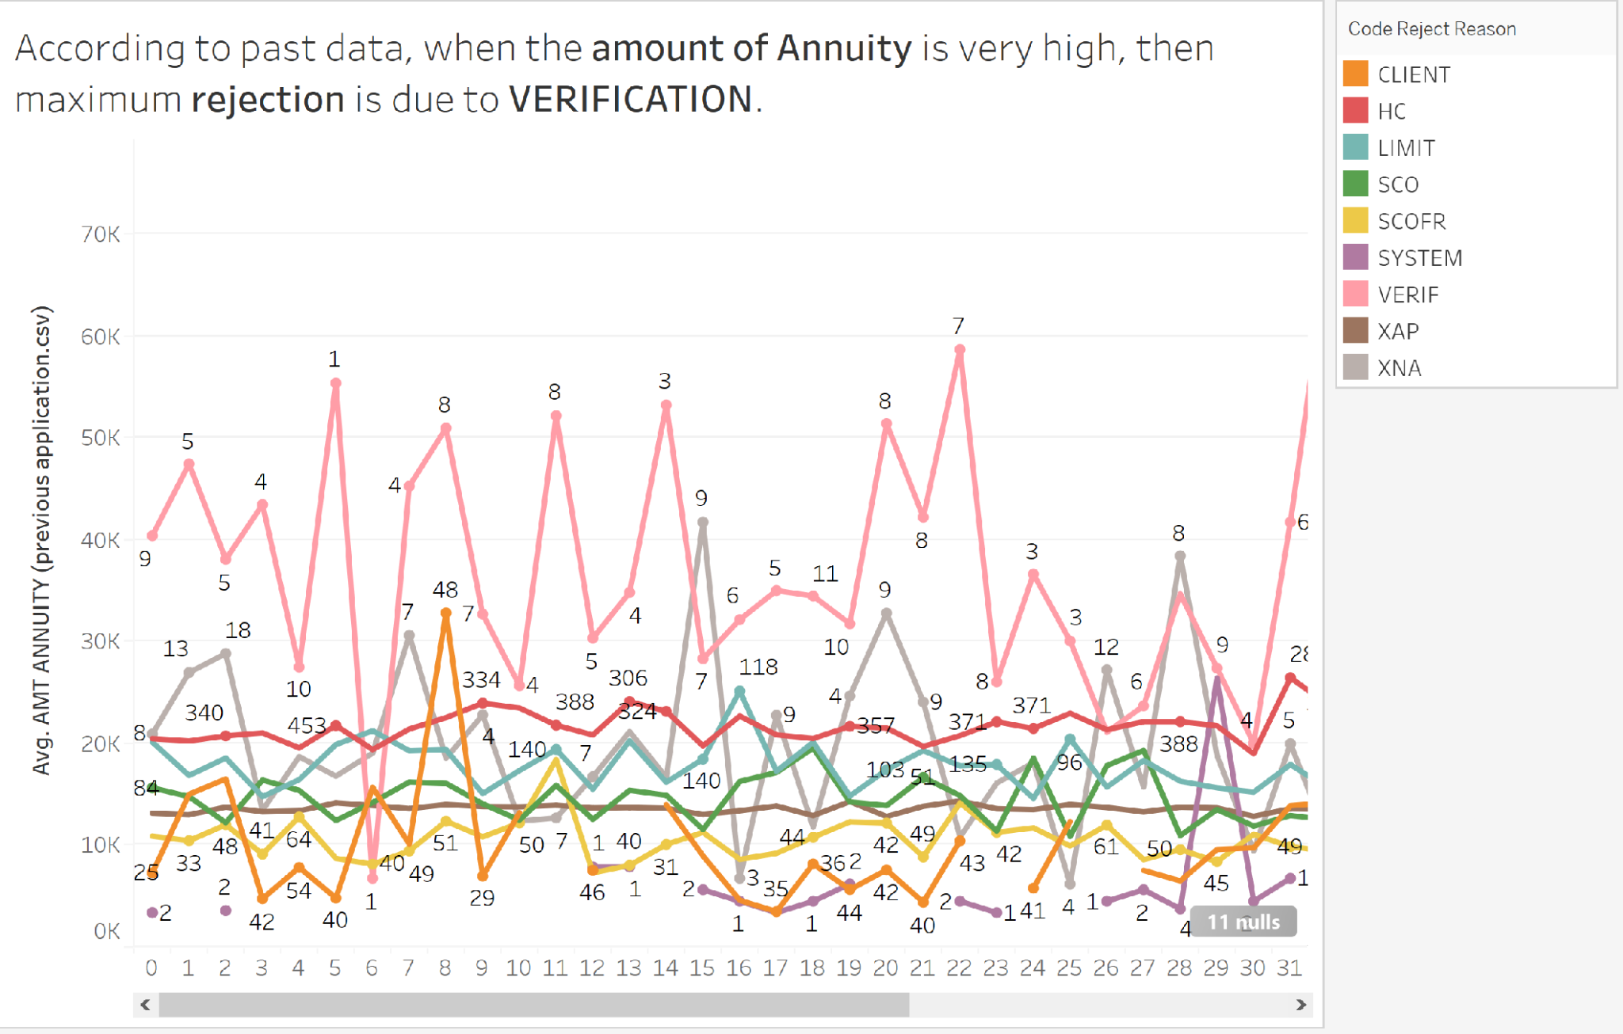

* The above plot is from the past data that shows the reason for rejection of the loan application. For Non-Defaulters, the reasons are clearly separated from each other based on the amount annuity(Can be seen in Tableau worksheet provided). But for Defaulters, these reasons get overlapped and for lesser annuity amounts also, they have been rejected due to the VERIFICATION reason.

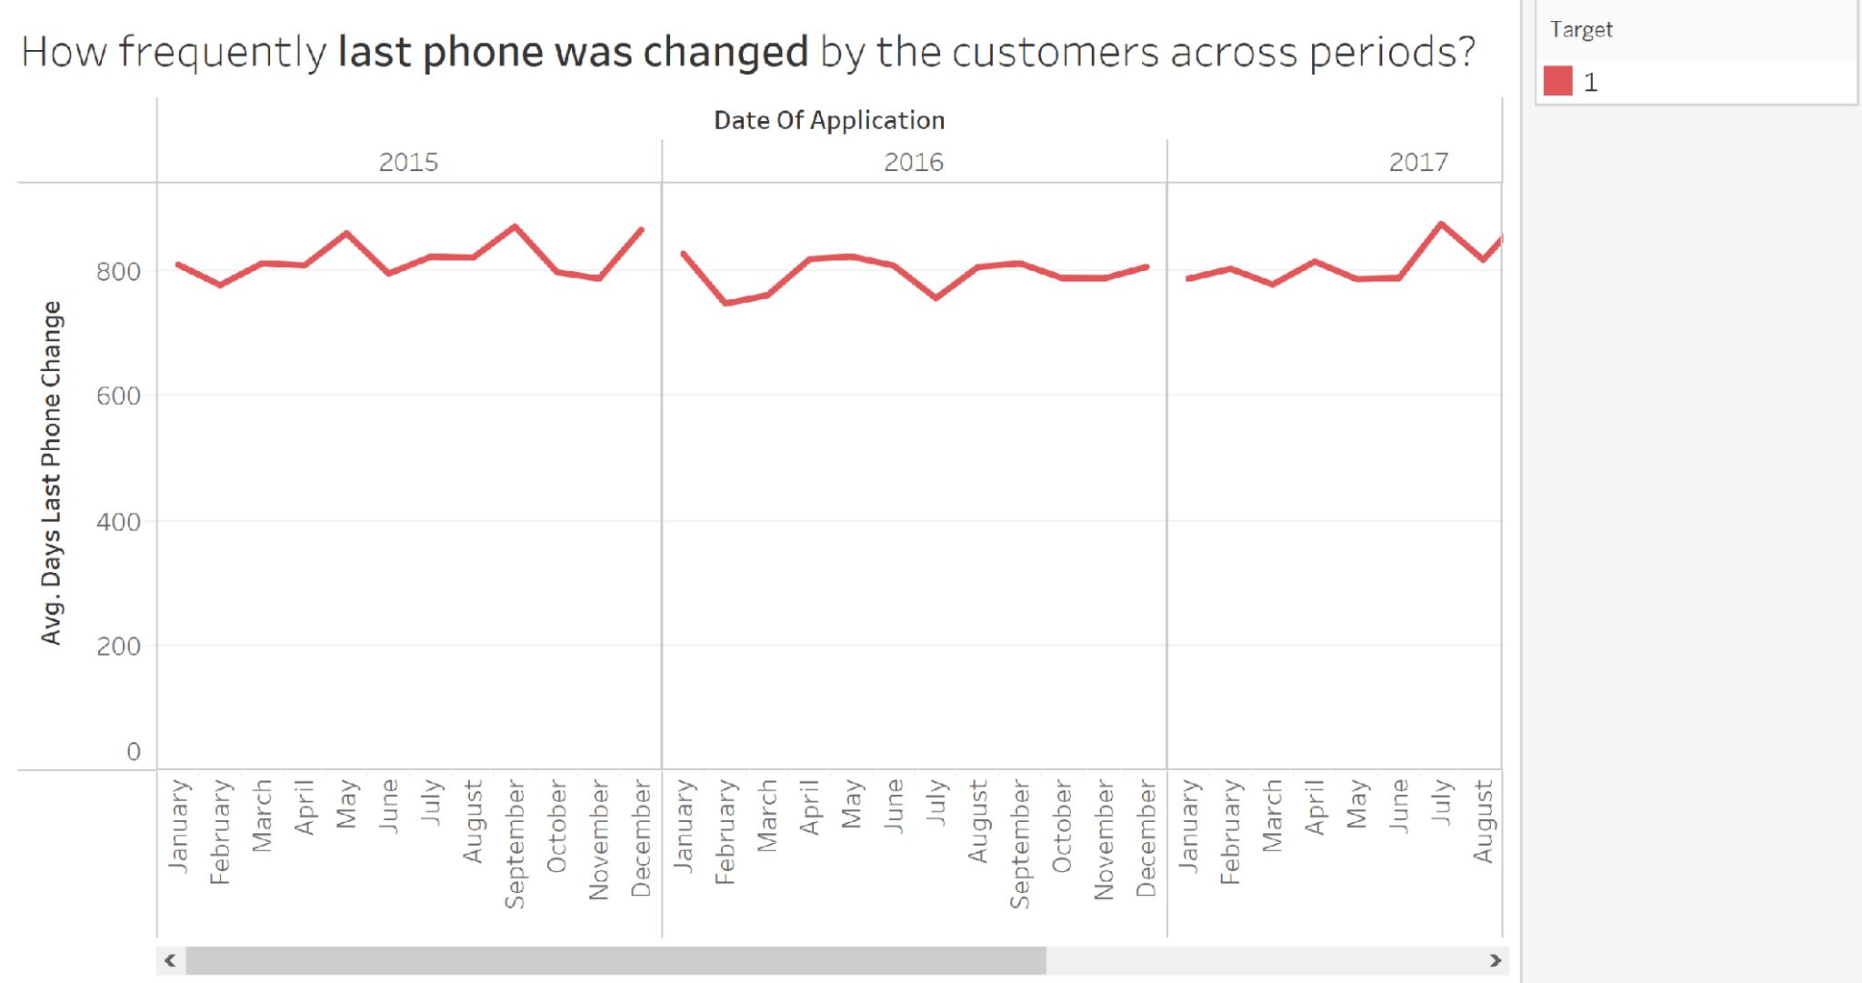

* The above plot shows how frequently the last phone was changed by the Defaulters. The variation is quite striking as compared to the non-Defaulters.

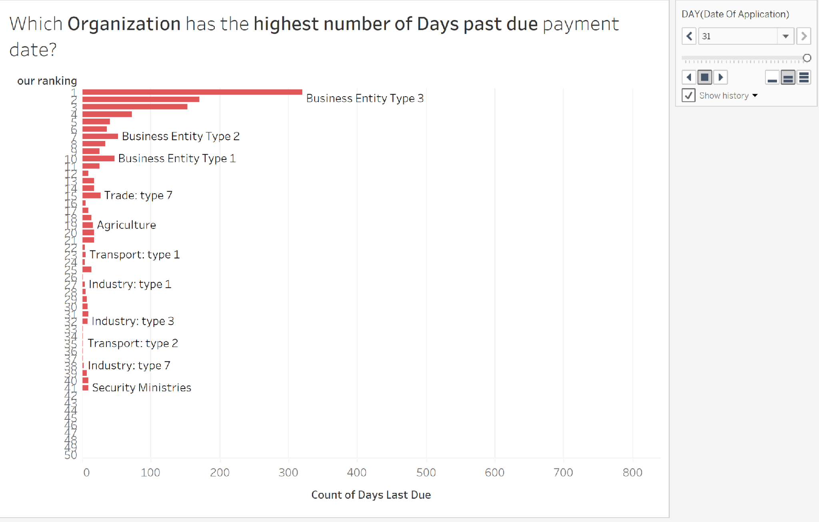

* Business Entity Type 3 - Organization has been on the top of the ‘days past due’ chart which ran for a period of 12 months. Banks or Credit Loan institutions should double check with this organization and put in stricter rules before handing them with loan amount.

## Section 6.3 : STREAMLIT

Streamlit is a data app framework, sometimes called a data dashboarding tool. Data apps are a fantastic way for data scientists to present their results. They give the audience interactive control of visualizations, engaging the user more intuitively with the narrative. Data app frameworks are code-based, which allows for more complexity than BI dashboarding tools. The framework seems to be growing quickly in popularity, accruing more GitHub stars (14,500) than any other data app framework except Plotly Dash, in less than two years. It seems well worth the investment of time and effort to learn Streamlit, from either the business or professional data science perspective.

Altair provides a powerful and concise visualization grammar for creating a wide range of statistical graphics quickly. Simply declare links between data fields, color, size, and so on, and the rest of the plot details will be handled automatically. You can use Altair to spend more time understanding your data and its meaning rather than figuring out the codes.

We have used a combination of streamlit and altair charts in order to develop a basic application which provides us with interactive graphs and declarative visualization. Using our merged data (which contains data from both datasets we used i.e. current loan applications and previous loan applications) we implemented a machine learning model i.e. logistic regression wherein it takes the input parameters and predicts the loan application status whether accepted or declined. Using labelencoder we converted the labels into a numeric form so as to convert them into the machine-readable form. The model showed an accuracy of around 80% thus, we proceeded with it since we didn’t want to focus much on modeling and focus more on the visualization aspect. Then, we passed the model object into the dump() function of Pickle which will serialize the object and convert it into a “byte stream” so that we can save it as a file called model.pkl and then de-pickle it into our streamlit python code using the load() function.

The streamlit and altair libraries have got all the parameters predefined, we had to only pass in our pickle file, our data, the input parameters and the logic of what graphs do we desire to plot. The below screenshot is the homepage of our streamlit application where on the left side we have provided a dropdown menu which contains two options: home and prediction.

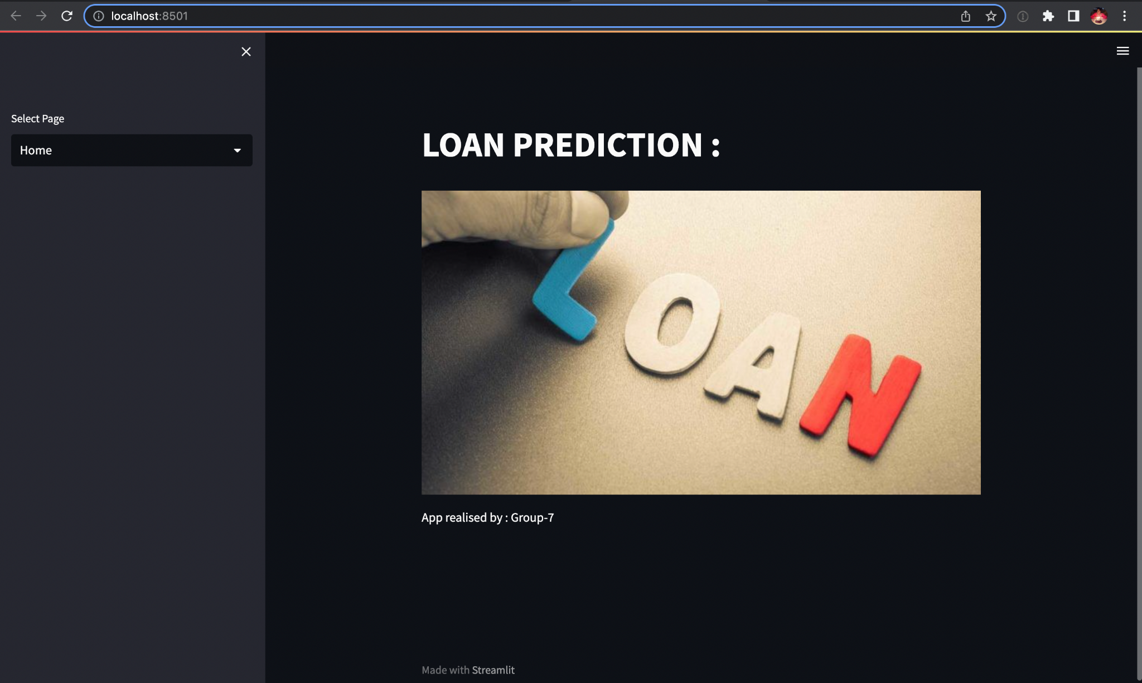

When we click on prediction it leads us to the form wherein the customer provides his/her input details and selections such as gender, age, marital status, employment status, education, income of the applicant, the loan amount and the loan term.

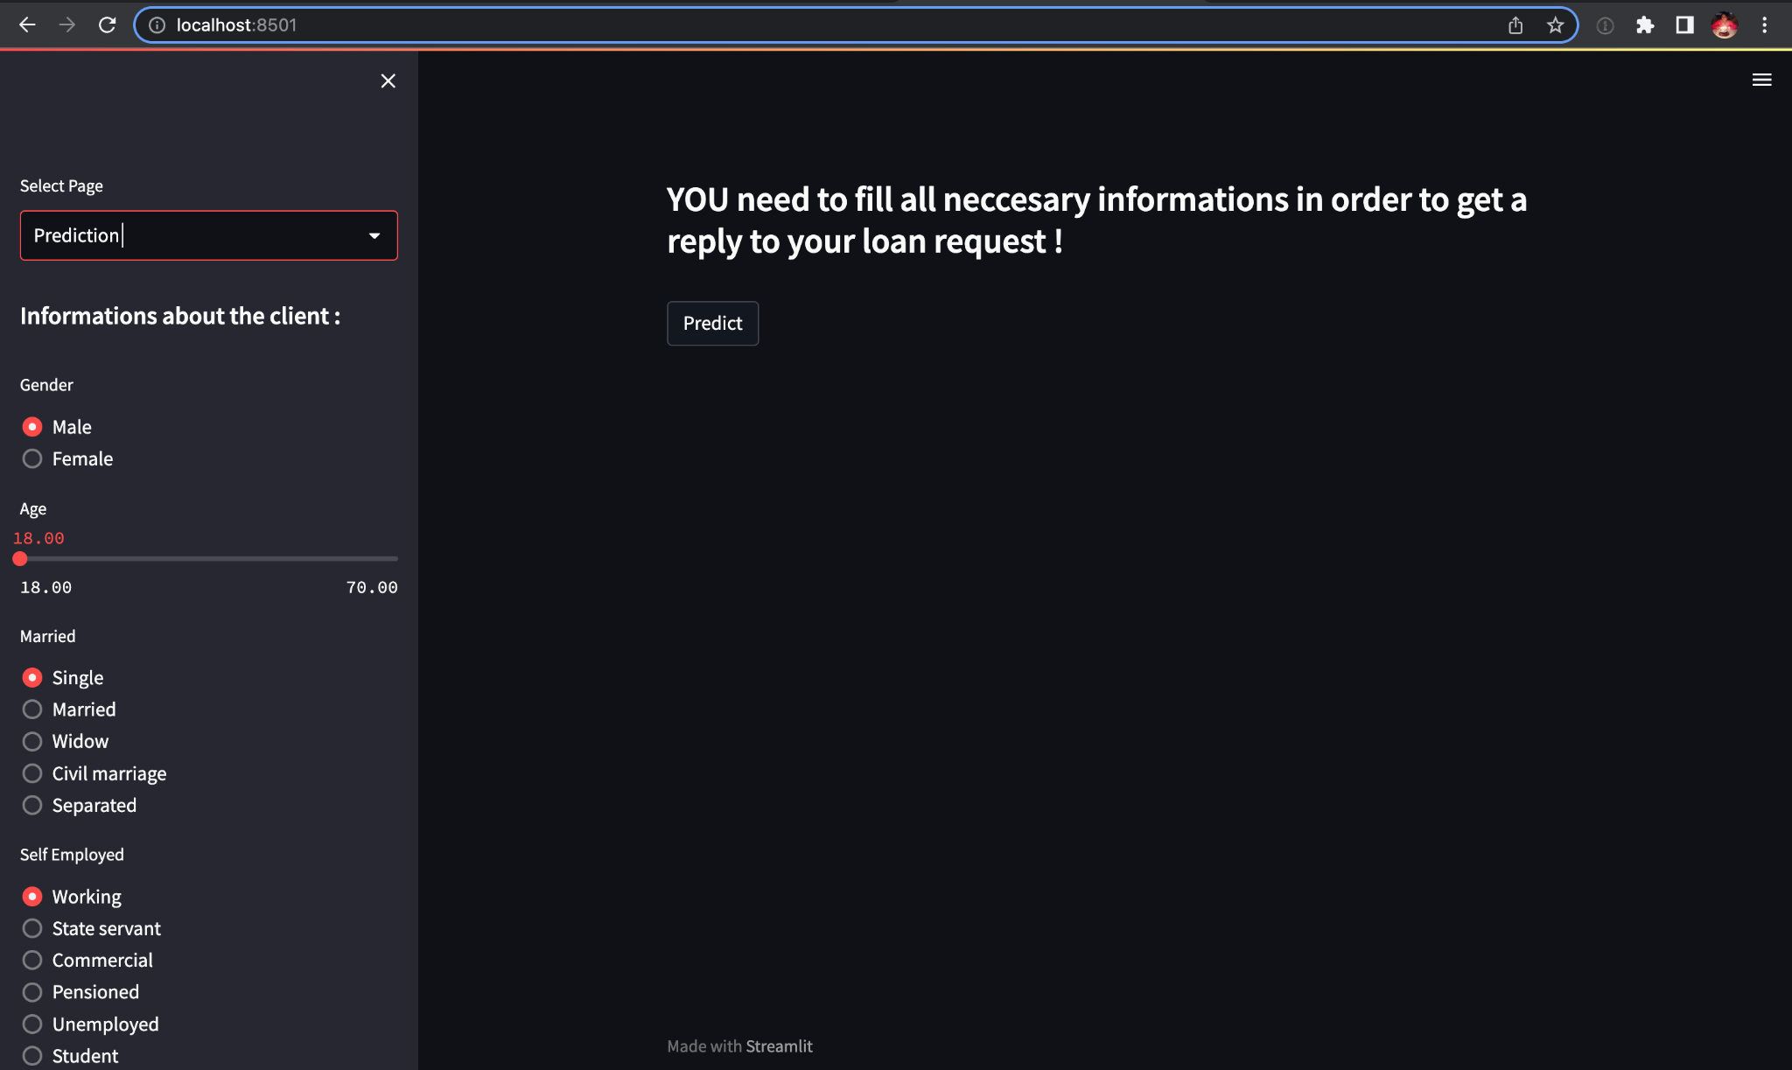

Once the applicant has provided the required information, on clicking on predict he/she will be getting the status of the loan application whether granted or rejected. In the below screenshot we see a scenario where based on the selected parameters the applicant will be granted a loan by the bank.

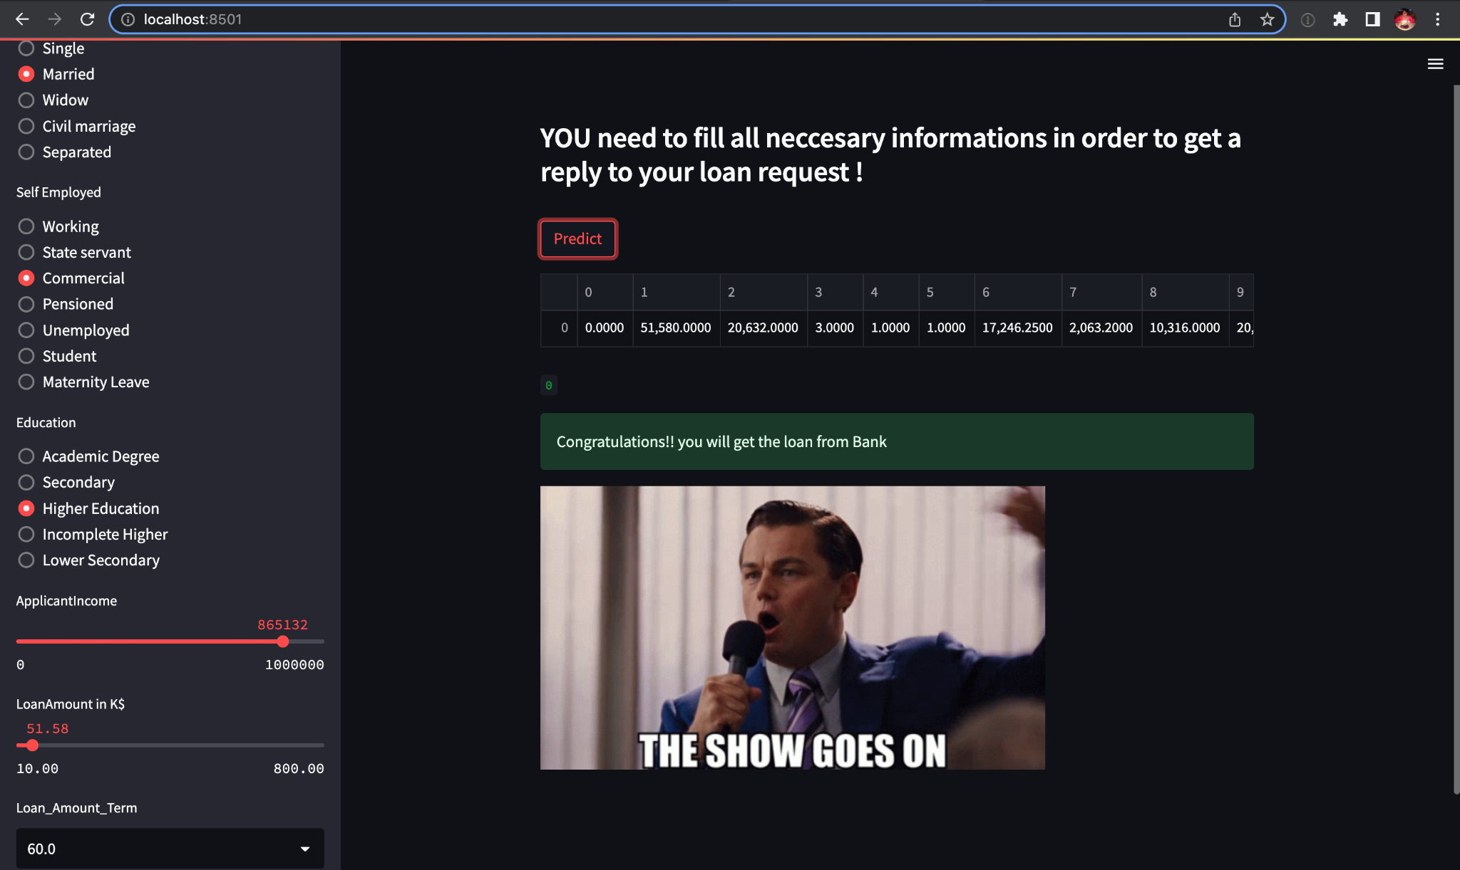

In the below screenshot we see a scenario where based on the selected parameters the applicant will be rejected a loan by the bank. So for the rejections we have tried plotting generic inferences as to what are the possible reasons and scenarios of a loan getting rejected.

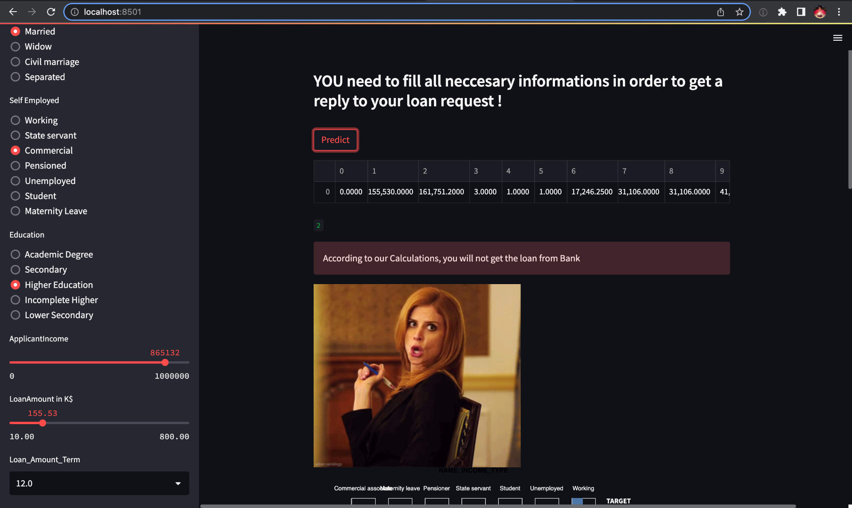

The below screenshot shows one among the three graphs we plotted to determine the inferences. The below graph is a dynamic plot between the loan amount credit and the price of the good based on which loan is being applied for.

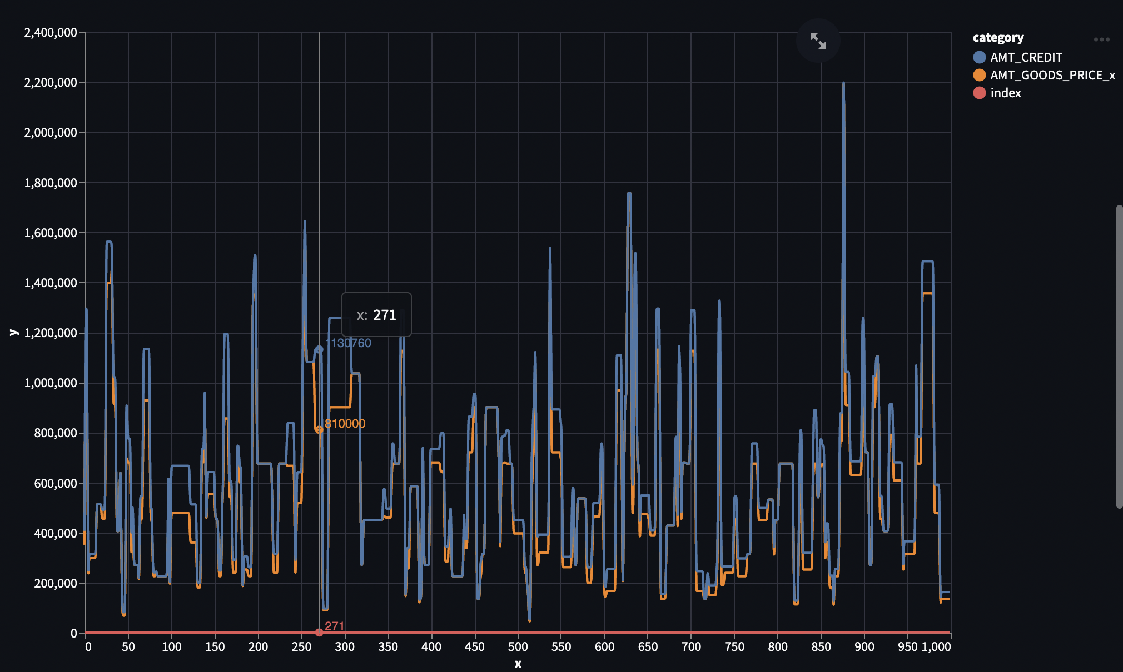

The below screenshot shows one among the three graphs we plotted to determine the inferences. The below graph is a stacked bar plot between the target 0 and target1 applicants based on their employment status. As we observe that mostly working applicants are able to pay the loans on time comparative to the other employers.

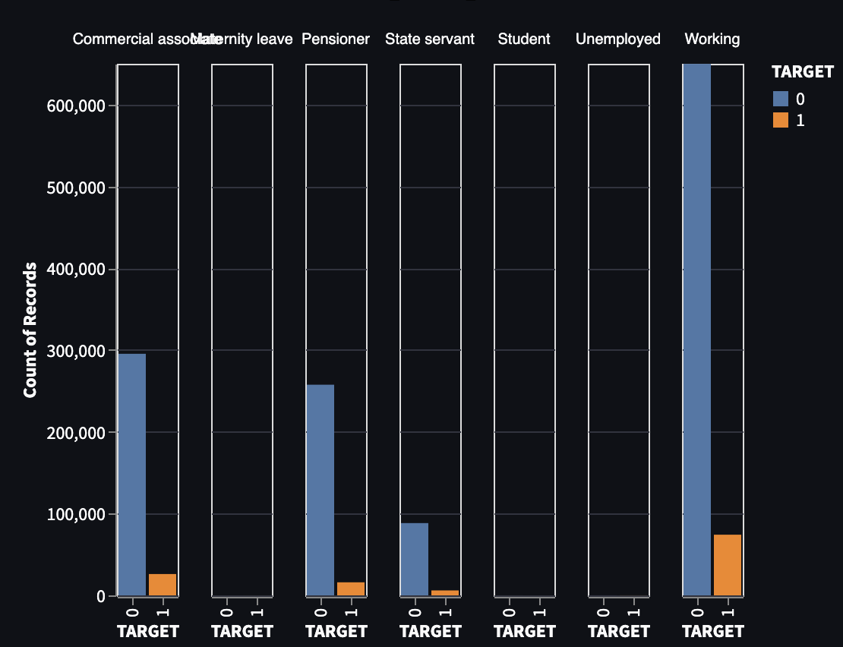

The below screenshot shows one among the three graphs we plotted to determine the inferences. The below graph is a pie chart for target 0 applicants based on their name status. As we observe that mostly married status applicants are majorly falling under target 0 when compared with other statuses.

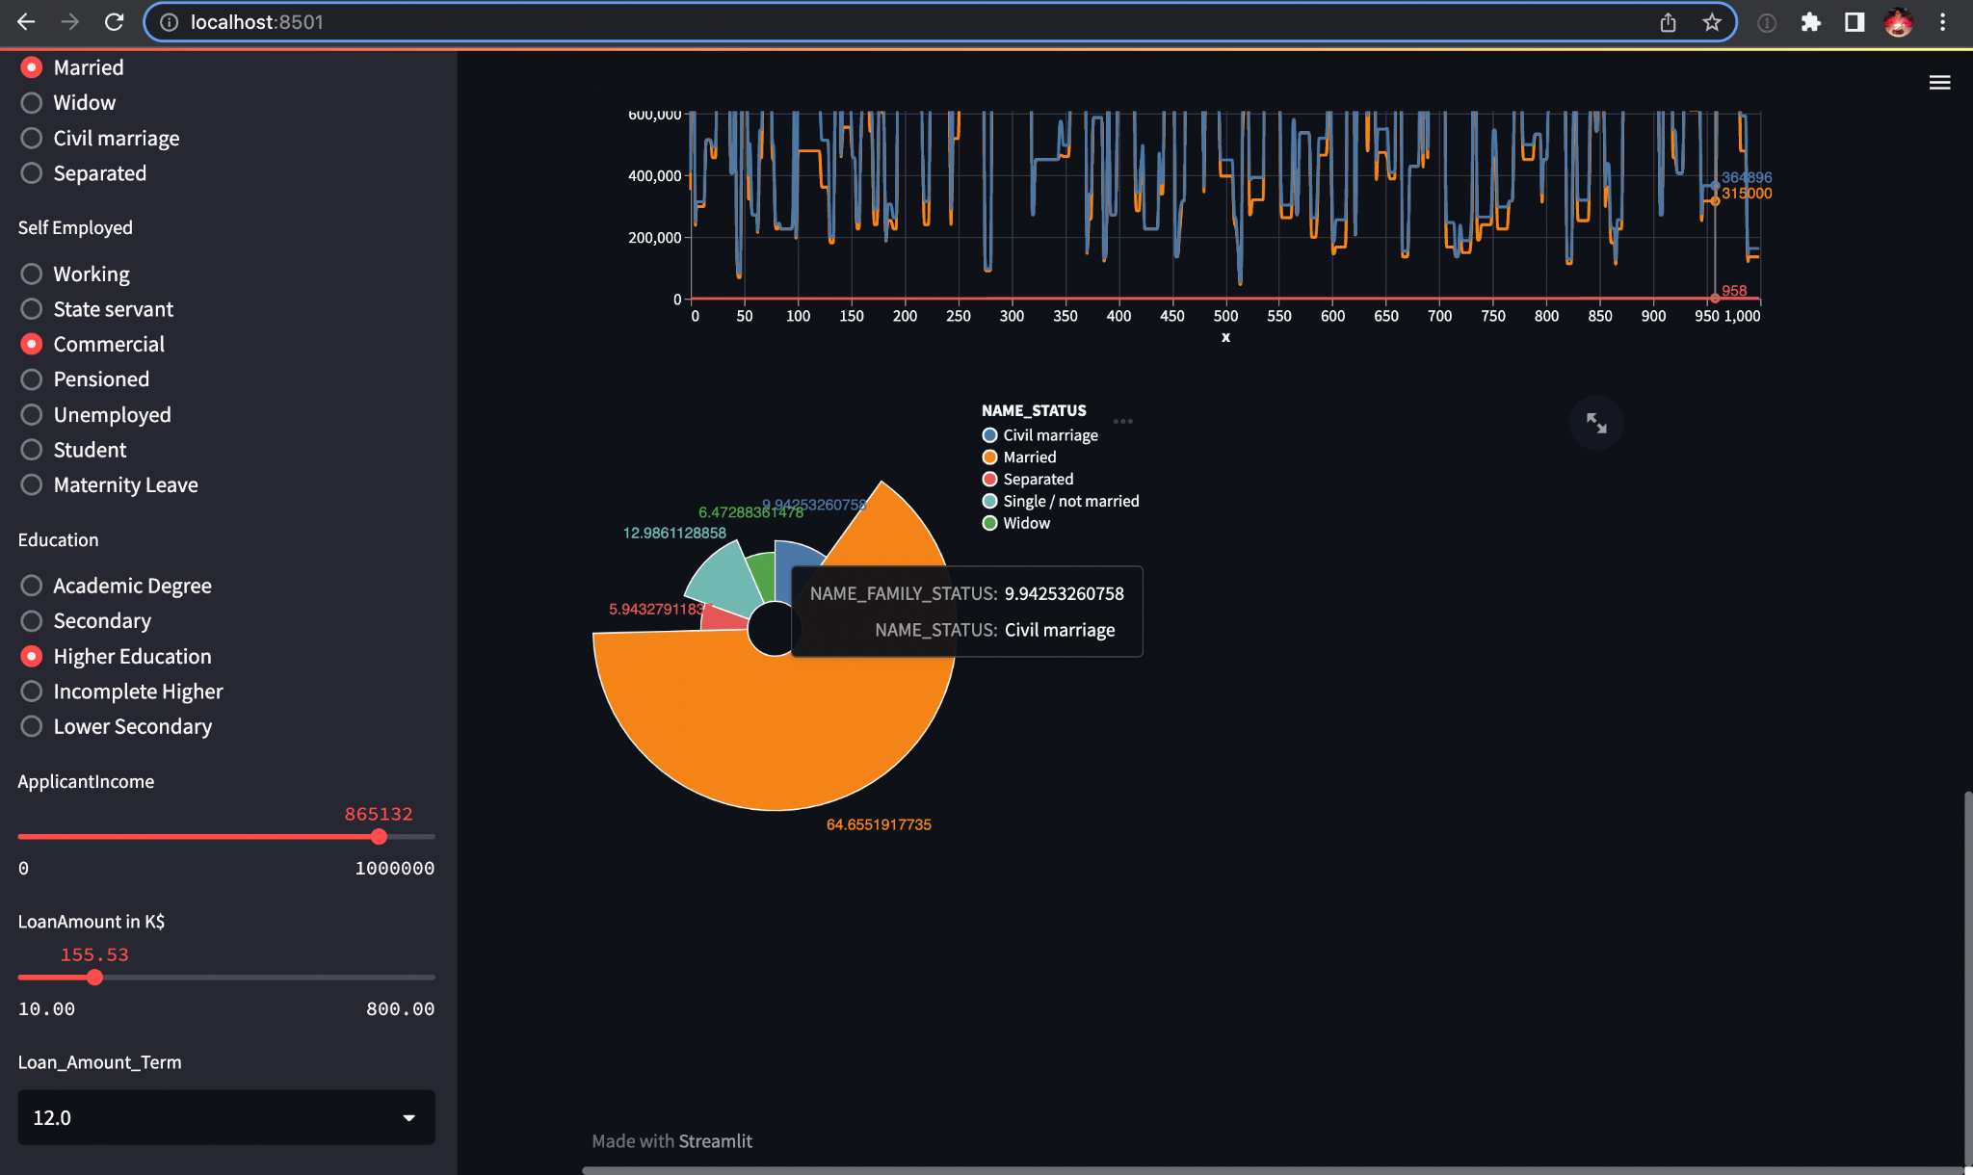

Streamlit offers many more wide varieties of graphs and charts for analyzing in depth. As a future scope, we try our hands on the rest of the features offered by streamlit as we just touched the tip of the iceberg and there’s a lot more to be explored. We can try and implement many more interactive charts wherein if we hover over a bit of the pie chart it shows another pie chart which has in depth details of that particular hovered portion of the pie chart. Similarly, for the time series the bar charts can be interactive as well wherein for all the respective time periods the charts keep varying and we can observe the pattern and trend more clearly and analyze it better and faster.

# Section 7: REFERENCES

<https://www.sciencedirect.com/science/article/pii/S0378426699000539?casa_token=2a6RTNYbicYAAAAA:2FgNR-4251RlaipUaT6d2ilBv9UlgzhWshR_AFBQU1PTRAG-JkMHWooqWV9_rRCM5D-sZJ-z>

<https://ieeexplore.ieee.org/abstract/document/9259208?casa_token=0hVeqxItIsUAAAAA:WQqOlep2xLiRPBvmJBYbjFkr4baDI6l5UQWGV437-Zx4ABj7qRZXLBcy4jgNijrQ9lfTmH3J>

<https://books.google.com/books?hl=en&lr=&id=5kgBZGGkYfsC&oi=fnd&pg=PT13&dq=credit+risk+analysis&ots=sJjqqk5xZl&sig=53_8ZH5yDP6WzcpvoLil8T2Z_Gw#v=onepage&q=credit%20risk%20analysis&f=false>

<https://www.researchgate.net/publication/257933657_Banks'_Risk_Management_A_Comparison_Study_of_UAE_National_and_Foreign_Banks_Journal_of_Risk_Finance_Vol8_No_4394-409_2007>

<https://lup.lub.lu.se/luur/download?func=downloadFile&recordOId=9066332&fileOId=9067075>